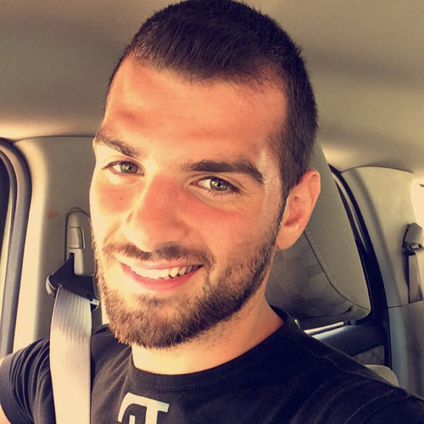 |  | marwan karroum  Beirut - Lebanon
professional summary  Business graduate and a Certified Digital Marketing Professional with over 2 years of demonstrated history in the non-profit organization industry and other fields (retail, fashion, …). My professional experience includes building and implementing strategies focused on social media platforms, SEO, email marketing, and AdWord largely for different sectors that I worked for (Humanitarian, Retail, Fashion). My experience expanded my ability to work in a team spirit which consequently helped me to manage my own tasks consistently.  Contact  PHONE:  +96170268693  EMAIL:  marwan.adib.karroum55@gmail.com  SKILLS  - MS Softwares: PowerPoint, Excel and Word.  - Social Media Expert  - Social Media Strategist  - SEO  - Communication Skills  - SEM  - AdWord  - Public Relations  languages  - Fluent in English and Arabic  - Beginner level in French  Extracurricular  - 06/2011 - 05/2013  Volunteer for the Red Cross - Ghana and Lebanon.  - 07/2017  Freelance Event Organizer in BIAF- Beirut.  - 04/2018  Freelance Event Organizer in Murex D’or- Beirut.  Hobbies  - Swimming  - Traveling  - Reading  - Music |  | EDUCATION and certifications  Digital Marketing Institute - Ireland  06/2019 – 12/2019  Certified Digital Marketing Professional (CDMP Certification)  Beirut Arab University - Tripoli  09/2013 – 06/2016  Bachelor of arts in Business administration concentration in management, marketing and strategies.  Beirut Arab University - Tripoli  12/2014 - 01/2015  International Computer Driving License (ICDL Certification)  WORK EXPERIENCE  Social Media and Communication Coordinator  MARCH Association - Beirut  11/2018 – 10/2019  - Assist the creation, conception, and presentation of social media strategies and integrated marketing campaigns.  - Build content for programs and marketing channels that includes both texts and visuals, ranging from social media campaigns, email blasts, landing pages, event collateral and press releases.  - Grow awareness of the programs with promotional campaigns across digital channels (including social, AdWords, Analytics, etc.).  - Prepare all needed communication materials for the workshops and events  - Handled the Database at the office.  - Organise and execute special events, working closely with colleagues, external partners and media, to ensure events are effectively scheduled, publicised and attended.  Community Manager  Solidere- Beirut  11/2017 – 02/2018  - Setting and implementing social media and communication campaigns to align with marketing strategies  - Provide engaging text, image and video content for social media accounts  - Respond to comments and customer queries in a timely manner  - Organize and participate in events to build community and boost brand awareness  - Coordinate with Marketing, PR and Communications teams to ensure brand consistency  - Report on weekly basis the social media engagements within the community.  Event Planner and Social media coordinator  Ziad Nakad Haute Couture  02/2017 – 10/2017  - Set the requirements and planned all of the events with respect to financial and time constraints.  - Book venues and negotiated all prices.  - Research vendors (catering, decorators, musicians) and filtered the best combination between quality and cost and hired personnel for each event.  - Build and execute social media strategies through competitive research, platform determination, benchmarking, and audience identification.  - Generate, edit, publish, and share daily content (original text, images, video or HTML) that builds meaningful connections and encourages community members to take action.  - Collaborate with other departments (customer relations, sales etc) to manage reputation, identify key players and coordinate actions.  Supervisor  Omar Shaick Company - Ghana  11/2011 – 06/2013  - Maintain staff by recruiting, selecting, orienting, and training employees and developing personal growth opportunities.  - Report to senior managers on weekly basis about the work.  - Provide quality service by enforcing quality and customer service standards.  - Contribute to team effort by accomplishing related results as needed to achieve targets.

