TAREK SAMIR  ABOU GHAZAL  PERSONAL DATA  Gender : male  Marital Status : single  Date of Birth : 5/4/1992  Nationality : Palestinian |  |  | 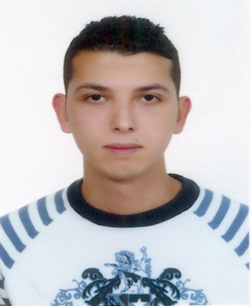
Address | : Beirut, Lebanon
Email | : tarekghazal625@gmail.com
Mobile | : 71/781069
CAREER OBJECTIVE
Work on the accounting program, and stock controller, the introduction of bills of sales and purchases of goods, as Atom communicate with suppliers about orders for goods and deal with them on price and the discount rate and method of payment.
Bring payments to suppliers by checks and bonds.
Actions such as sending administrative secretarial, fax and e-mail, archiving, printing, etc. ....
WORK EXPERIENCE
august 2014 till present | junior Accountant
Full Time | Barakat international - Beirut
Work on the accounting program bee business belonging to the company(ACI):
- Processing all the following entries : journal voucher,puchases,sales,Payment voucher, receipt voucher ,credit note, and debit note.
- A review of the balance of customers and suppliers.
- Reconciliating cash and bank accounts.
- To open accounts for customers and new suppliers.
- Preparing financial reports to support management decision making.
- Handling payables and receivables accounts.
- Assist in providing tax permits
- Be part of the end of month closing.
In addition to a lot of matters relating to administrative and public accounting.
January 2014 till august 2014 | Assistant Accountant
full Time | accounting office - Beirut
November and december 2013 | Trainee at Talal Abu-Ghazaleh & Co.
full Time
October 2013 - Part time | Trainee at UNRWA
EDUCATION
2010-2013 | Lebanese University
 | Bachelor's degree in Accounting & Auditing
2007-2010 | jamil rawass Official School
 | Bac 2 Degree in (economy – sociology)
LANGUAGES
 | Spoken Written
Arabic | Very Good Very Good
French | Very Good Very Good
English | Good Good
Computer proficiency

- Internet
-Microsoft Word
-Microsoft Excel
-Microsoft PowerPoint
-Accounting (Bee Program)
-Outlook express
SKILLS
-Excellent Communication, Organizational and Interpersonal skills
-Good skills in using the Internet
-Resourceful, Ambitious, and a Fast Learner
-A determined and responsible leader
-A strong team player, works well individually or as part of a team
-Goal oriented
-Relates well to a range of people
-Organize and supervise social and entertaining events

