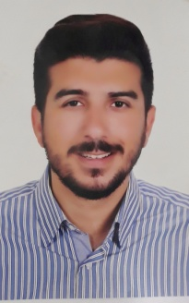
Majid ASSAF
Date of birth: March 03, 1992
Address: Achrafieh-Sioufi, Beirut, Lebanon
Mobile: 00961-71-067235
E-mail address: majid.assaf@hotmail.com
EDUCATION
2012 – 2016: BA in Business-Finance - Lebanese University
2009 – 2010: Baccalaureate II – Socio-Economics - Sacre-Coeur College - Gemmayze
SKILLS AND INTRESTS
- Bank reconciliation
- Data entry of all transactions, receipts and payments, invoices and purchases on daily basis ( Gap - Navison - Focus)
- Prepare payments for suppliers
- Reconcile statement of account with suppliers and clients
- Prepare and submit social security and tax reports in coordination with the auditor
- Preparing sales invoices
- Preparing end of month financial reports
- Prepare monthly payroll
- Prepare all documents regarding new employees at NSSF and declare them to MOF
- Principles of taxation
- Excellent research and problem solving skills
- Time Management, Budget Management, Communication Skills, Flexibility, Positivity, Team Work, Pressure Handling Skills, Organizational Skills, Body Language
Computer: Proficient in Microsoft Office (Word, PowerPoint, Excel, Outlook)
Languages: Fluent in French, English and Arabic
Interests: I have great interest in Photography, Sports (Skiing, Hiking, Jogging, Swimming, and Tennis), Camping, Music (Piano Playing), Technology and Reading
PROFESIONAL EXPERIENCES:
December 2018 - till present :Accounting - Hermes tourism and Travel (Credit Libanais Group)
July 2018 - September 2018: Accounting - Ajafco, Mkalles
July 2017 - 2018: Accounting-BMB, Baabda
Summer 2014: Internship Teller/ Customer Service – Bank of Beirut, Jal el Dib
PROFESSIONAL REFRENCES
References are available upon request

