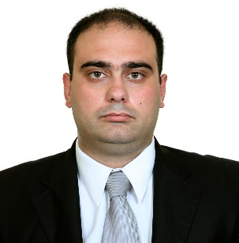 | Hassan Al Najjar  Kfersaron El Koura North Lebanon  Email:hassan.j.al.najjar@gmail.com  Cell number: 71 356 429

Career Objectives:

To pursue a career in a thriving business where I can utilize my skills and gain further experience while enhancing the corporation’s productivity and reputation.

Education:

Lebanese International University MBA,  Major of finance  With accounting courses: Cost control, Auditing. | 2016-2017
Lebanese International University Bachelor of Business Administration,  Major Banking and finance (with honor )  With accounting courses: Project management, Cost control, Intermediate accounting 1. | 2012-2015
Freddy At Allah Institute kaferakkaa | 2009-2012

Work Experience:

SECURITY & SAFETY SOLUTIONS s.a.l  (Accountant) | 21/9/2019- present
- Data entry (inventory, purchase, selling).
- Calculate taxes.
- Preparing financial statements, and financial reports.
- Preparing (R5, R10), VAT, Payroll
- Sales invoices and give permission for sales order.
- Controlling and monitoring stock.
- Filling
- Collection.

Raied AL-Mouraabi auditing office  (Senior Accountant) | 1/1/2019-20/9/2019
- Data entry (inventory, purchase, selling).
- Calculate taxes.
- Preparing financial statements, and financial reports.
- Preparing (F (1, 2, 3), R5, R10), VAT.
- Trainer for the new employees and for the student trainees.
- Supervise and control employees and trainees.
- Dealing with client and banks.

Accurate Accounting  (Junior Accountant) | 1/3/2017-31/12/2018
- Data entry (inventory, purchase, selling).
- Calculate taxes.
- Preparing financial statements, and financial reports.
- Preparing (F (1, 2, 3), R5, R10), VAT.

Insurance consulting with BANKERS insurance  Part time | 2017
- Explain different type of insurance programs.
- Explain the benefits of having personal life insurance program.
- Create the best program to each client.

Accounting project:

Epsilon Accounting System 2019

- Accounting consulting and developer
  - Create the chart of account.
  - Make the Auto-links between the accounts.
  - Testing the effectiveness of the system.

Skills:

Marketing skills
Corporate Communication
Creative Team Leadership
Languages Arabic, and English
Software: SPSS, MS Office (word, Access, Excel, PowerPoint, Project management), Accounting software (SOFTWAVE, EPSILON, VIOLIN), restaurant management software (OMEGA).

Activities:
- Reading
- Hunting

Portfolio and References available upon Request

