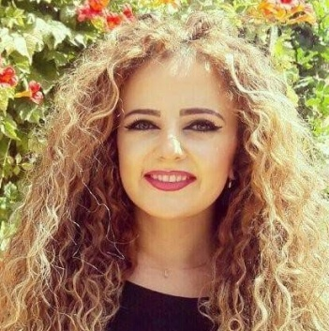
Mrs. Yara Chaaban
Vision & objective
Intend to get a position to utilize my skills and abilities into practice for mutual growth and benefit and make endeavors towards the way which is innovative, creative and excel in my field.
PERSONAL INFORMATION
- Father name : Elias
- Date of Birth : 14-11-1993
- Address : Dekweneh, Metn
- Nationality : Lebanese
- Mobile Phone : +961 (76)607860
- Email Address : yara_chaaban_93@hotmail.com
- Marital status : Single

EDUCATION
- 2017: LT /Audit and accounting.
IPNET of Dekwaneh
- 2013/2014 : TS Accounting.
Technical Institut of dekwaneh.
- 2010/2011: Lebanese baccalaureate / sociology-Economy.
Official Ras Baalbak School .

PROFESSIONAL EXPERIENCE
- I&I, Accountant (9-2018-…)
- Entotox , Accounting Executive & HR Coordinator.(1 year)
- Classic burger , junior accountant (1 year)
- Stage Bureau « AFFCA » (Directeur Joseph El Asmar)

COMPUTER SKILLS :
- Systems : Windows
- Microsoft Office: Word, Excel, Power Point.

LANGUAGES SKILLS:
LANGUAGE | SPEAKING | WRITING | READING
ARABIC | EXCELLENT | EXCELLENT | EXCELLENT
ENGLISH | GOOD | GOOD | GOOD
FRENSH | GOOD | GOOD | GOOD

Hobbies
- Sports
- Dance
- Music
- reading

