AMAR SALEH
RADIOTV/COMMUNICATIONS
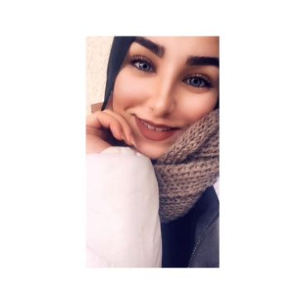
Address: Lebanon, Bekaa, Majdal Anjar
Mobile number: +961 70220107
Email: amarsaleh987@gmail.com

CAREER OBJECTIVE
Seeking a distinctive career opportunity which enables me to relate theory of study into practice and acquire progressive knowledge and experience in the field of radio and TV and any social field.

EDUCATION
Lebanese International University – Bach 2017
Bachelor’s Degree in Radio TV Communication Art.

WORK EXPERIENCE

IRC English Teacher: (2019)
- Organizing & delivering classroom lectures.
- Evaluating a students’ class work & assignments
- Preparing classroom & coursework materials, homeworks & handouts.

UNDP Pr officer: ( 2015-2017)
- Organizing development and cultural projects for refugees in the region.
Projects that we did:
- Marathon for lieutenants in Bekaa.
- lectures about how to resolve conflicts.
- Awareness campaigns for youth problems.
- Collect donations and distribute them to the poor.

Website manager at AL-Raii magazine: (2018 – 2019)
- Writing political & social news on the website of the magazine.

Presenter at radio PAX: (2017)
- Presenting social program named “عالوتر”

PERSONAL SKILLS
- Filming Skills: ability to do a short documentary that lighten on a critical situation.
- Excellent oral and written communication skills in English and Arabic.
- Excellent interpersonal and networking skills
- Ability to work within deadlines, prioritizing competing demands under pressure.
- Demonstrated project management and organizational skills as well as an attention to detail.
- Creative problem Solving.

REFERENCES: Furnished Upon Request

