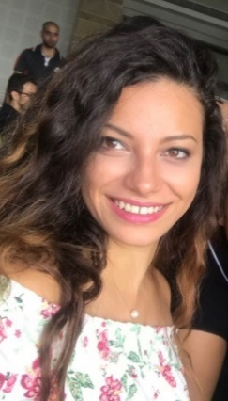
Khouloud Ghassan Shediak
Miniara, Akkar, Lebanon
Mobile : +961 71 868840
E-mail: khouloud.shediak@gmail.com
Personal Information

- Date Of Birth: 31th March 1993
- Nationality: Lebanese
- Marital Status: Married
Education and Qualifications
- September 2017- June 2019: MBA– Lebanese International University – Tripoli Campus.
- October 2011- June 2016: BA in Accounting Information System – Lebanese International University – Akkar Campus.
- September 2010- May 2011: Bac II in Economic and Sciences – Modern School North Lebanon- Miniara
Profile
- Works well independently, or in a team.
- Analytical, drive to surpass goals, and multi-task oriented.
- Ability to grasp technical concepts quickly and easily.
- Ability to work under pressure.
- High Management skills.
- Time Respect.
- Easily dealing with clients (especially parents)
- Deal with complaints or conflicts in a wise way
Languages
- Arabic: Mother-Tongue/ Fluent (Reading, Writing, and Speaking)
- English: Fluent (Reading, Writing, and Speaking)
Computer Skills
- Excel, Word, PowerPoint
- Courses in: Photoshop
Personal Interests
- Traveling
- Reading
- Getting to know people from different cultures
Professional Experience
- 2013-2018: Working as Accountant at Lebanese International University (Akkar campus)
Duties:
  - Set payment vouchers for students
  - Precise data entry on the accounting system (NORIA) of the university as account payable transactions
  - Precise data entry on the accounting system (NORIA) of the university as account receivable transactions
  - Paying by cash or check to the suppliers according to official documents
  - Issuing receipts according to payments
  - Preparing financial reports on daily, weekly or monthly basis depending on what is requested
  - Assist the Director in setting the financial aid
  - Managing the petty cash
  - Archiving all the financial documents hardcopy in a filing box.
  - Buying all the office equipment needed
  - Bank visits for cash deposit
  - Scanning all the financial documents for sending them by email upon request and archiving them as soft copy.

- 2013-2018: Working in the Student Affair Office at Lebanese International University (Akkar campus)
Duties:
  - School Visit to orient students on the majors found in the university by preparing a presentation
  - Preparing all kind of attestations for students
  - Plan and execute the graduation ceremony
  - Plan and execute all the events done in the campus
  - Finalizing NSSF transactions
  - Preparing Report weekly, monthly and yearly
  - Help students to fill applications
  - Manage the final exam schedule
  - Seeks under solving students problems
  - Work in filing and maintains the document related to each students
  - Manage with an assistant the inventory and prepare a report when requested

References and Portfolio
References and portfolio are available on request.

