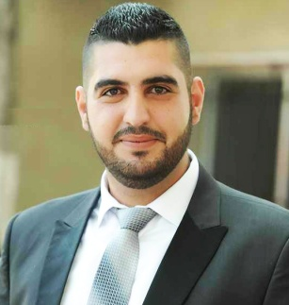
OssamaShbat
Lebanese, Single, 01/01/1993
0096170-682642
ossama.shbat@gmail.com

Expectation
Seeking a mid-career position in sales, Human resources, or public Relations, where my strong analytical and people skills, will be utilized for the best of the company and my career development.

Education
2010-2013
BT of sales and trading relations
2013 – 2016
Bachelor of Marketing - Jowaya University

Experience:

● 2013-2016: Khaldoon Pharmacy- Rachaya/Lebanon
- Assisted the main pharmacist in daily sales, weekly and monthly inventories, and putting orders

● 2015-2016: Al-haj beton - Bekaa/ Lebanon
- project coordinator in their Bekaa projects, assisting in workers attendance, transportation, materials inventories, and other needed on site tasks

● 2016- 2018: Ground engineering contractors - khobar/Saudi Arabia
- Human resources coordinator and daily documents translator

● 2019 Vitas - salesman - Bekaa/ Lebanon
- salesman in loans department (stopped due to recent situation)

Language:

● Arabic reading speaking and writing very good
● English writing reading and speaking very good
● French writing reading and speaking good

Computer skills
Microsoft word, excel, and PowerPoint.

Strengths:

● Self-motivated
● Team player
● Hard worker
● Ambitious

Volunteering

First aid volunteer at the Lebanese red cross since April 2010 till Dec 2017,
Active Member of “Nahna Rachaya” Association.

Training:

● Mountain rescuer after going through three levels of mountain rescue workshop (A-b-c) years 2012-2013
● Psychological support training (2014)
● Crisis and disasters management (2015)
● ambulance driver at Lebanese red cross
● report preparing courses at 2013

Hobbies:
Football, Basketball, and all social activities

All documents are available upon your request

