ELIE AL JAMMAL
Curriculum Vitae

PROFILE

Graduated student of interior design looking to attempt high experience level with aspiration to acquire more interior skills. Trustworthy, and great team player. Keen to explore every working opportunity and develop it to its maximum. Analytical and hard-working with a practical hands-on approach, always perseveres to achieve the best results , having strong talent for identifying costumer needs and delivering fascinating interior decoration services to the client satisfaction and requirments .

PERSONAL INFORMATION

- Nationality :Lebanese
- Date of Birth : December 21 , 1995
- Marital Status : Single
- Mobile number :03173784
- Email address :elie.jml98@gmail.com
- Current Place : Lebanon
- Adress : Halba , Akkar

EDUCATION

Graduated student in Interior Design at Lebanese International University . In addition , I cherished a certificate in media communication skills from Al Jazeera Channel .
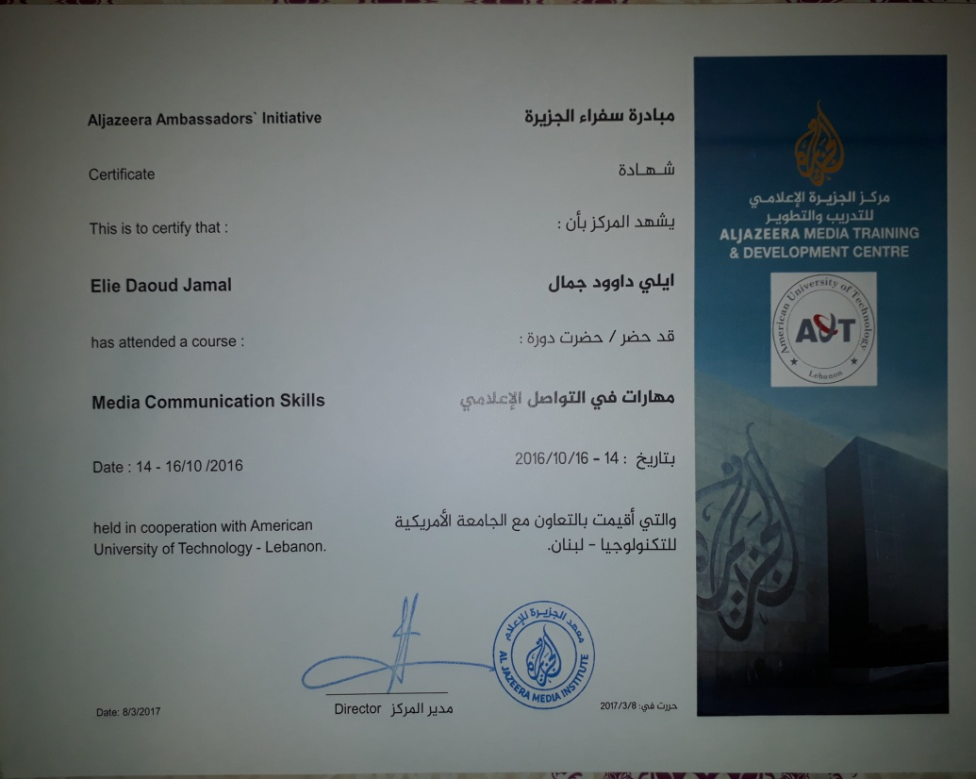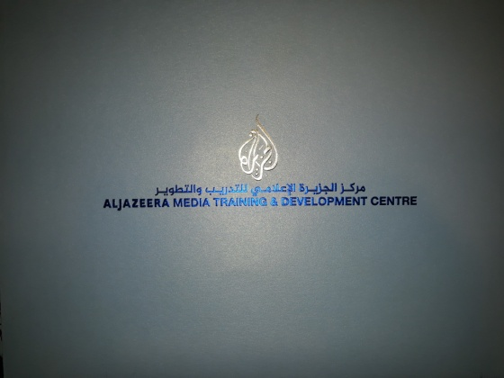

STRENGTH

- Good Listener
- Have excellent communication and presentation skills
- Ability to work under pressure and meet deadline

SKILLS & ABILITIES
- Expert 3D modelling, animation and visualisation skills
- The ability to work on multiple projects simultaneously and efficiently
- Creating realistic interior design sketches by hand
- Expert 3D modelling, animation and visualisation skills
- Experienced in a variety of drawing, modelling and editing software: AutoCAD, Autodesk 3ds Max, Adobe Photoshop.
- Language Proficiency : Fluent in written and spoken Arabic, English
- Computer Skills: Extensive knowledge in Microsoft Office programs
- Very High motivation and seeks perfection.
- High work ethic and standards to achieve social value in what I do.

KEY ACHIEVEMENTS

- Looking to Build a strong Background in interior design and achieve perfect skills .

WORK EXPERIENCE & SKILLS

- Decorating in a flower shop: seven years at Lolly Flower
- H.R. and Decorating in the shop of household utensils: 1 year at Skaf Store
- Joined a page as a partner for 1 year ( All Season -Event )
- Owned a page for 1 Year ( Golden Events ) –(closed it for personal reasons )
- Architect in jaloul devloppement(two month because of the situationin Lebanon
- Teaching private lessons at home (agenda)
- Photographer(2 month due to lack of time)
- Activities for children
- Teaching of drawing
- Print(papers,clothes,glass,cap….)
- UNHCR(submit food for the refuges syrian )

EXTRA ACTIVITIES/ HOBBIES
Professional Drawer

REFERENCES
Available upon request according to personal information mentioned above .

