Switzerland
Switzerland is a mountainous European country, known for its to numerous lakes, villages and the high peaks of the Alps. Its cities contain medieval quarters, with landmarks like capital Bern’s Zytglogge clock tower and Lucerne’s wooden chapel bridge. The country is also known for its ski resorts and hiking trails.

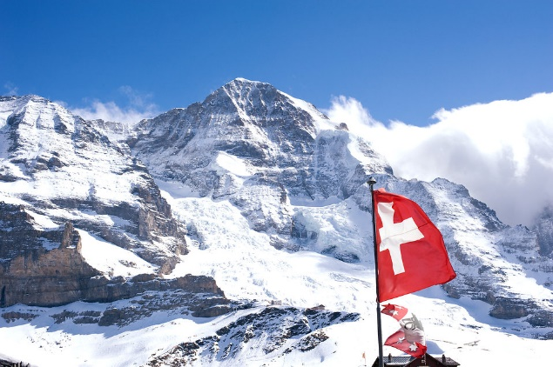
Tourism in Switzerland has peaked over the last couple of years compared to other European nations. Switzerland’s natural beauty has caught eyes of many tourist making it number one across Europe. One of the most popular places known in Switzerland is the extraordinary Alps. The Swiss Alps comprise almost all the highest mountains of the Alps, listed in the table below.
Name of Mountain | Height
Dufourspitze | 4634m
The Dom | 4545m
Liskamm | 4527m
Weisshorn | 4506m
Matterhorn | 4478

Swiss chocolate is famous across the world, with good reason. The nation has a long history of excellence in the field, and many of today’s chocolatiers still use traditional recipes and make every sweet treat by hand. Switzerland is for real chocolate lovers: you won’t find anything here but the best. It has the world’s largest manufacturing company Lindt. Other companies include Nestle.
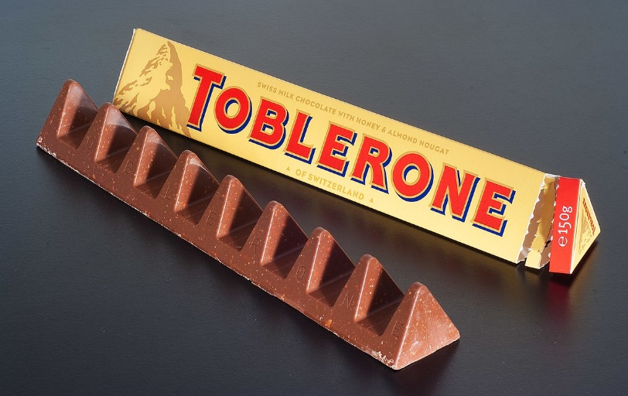
References
https://www.google.com.lb/search?q=swiss+chocolate&source=lnms&tbm=isch&sa=X&ved=0ahUKEwik3frhguPdAhUG6oMKHfO7AbcQ_AUIDigB&biw=1280&bih=610#imgrc=_9fEPHn_pxrkDM:
https://www.google.com.lb/search?ei=ZuewW_2gMIvojwTawp-YCQ&q=switrland+and+therre+chocolates&oq=switrland+and+therre+chocolates&gs_l=psy-ab.3..33i21k1j33i160k1.3066.12664.0.12947.31.26.0.0.0.0.554.3939.2-5j5j1j1.12.0....0...1c.1.64.psy-ab..19.10.3293...0j35i39k1j0i67k1j0i131k1j0i20i263k1j0i10k1j35i304i39k1j0i13k1j0i13i30k1j0i8i13i30k1.0.gAlKXMj-EAk
https://www.google.com.lb/search?ei=QeOwW8OBKaK_jwSthoawAQ&q=name+of+switzerland+chocolate+manufacturers&oq=name+of+switzerland+chocolate+manufacture&gs_l=psy-ab.1.0.33i22i29i30k1l2.925222.945032.0.947860.52.39.2.4.4.0.1399.6490.2-5j3j4j2j0j1.16.0....0...1c.1.64.psy-ab..30.22.7325.6..0j35i39k1j0i67k1j0i22i30k1j0i22i10i30k1j0i20i263k1j33i21k1j33i160k1j33i10k1.808.-VdXsIdA3Ng

