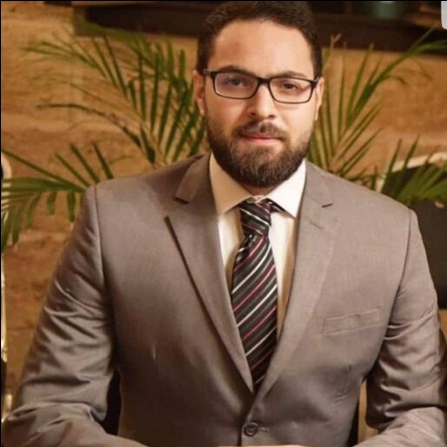BILAL TAREK BAYTIE

Contact Details

- Name: Bilal Tarek Baytie
- American / Lebanese
- Date of Birth: June 10 – 1997
- Adress: Tripoli_Abi Samraa_Al Manar Street
- E-mail adress: bilalbay123@hotmail.com
- Facebook: Bilal Baytie
- Mobile number: 70-398537

Opening statements

I am a very active person, able to handle multiple assignments under stress and
pressure. I am looking forward to increase my professional background in business field especially in marketing.

Skills and Technical / Software Skills

- Word
- PowerPoint
- Excel

Personal memberships and career view

- Participated in ESP program for advanced bussines courses adopted by DPNA
- Participated at " management and marketing " workshops at Bayt Al Fan-Tripoli
- PR board representative in azm youth association
- Marketing and customer service strategic developer for lebanese international university volunteering team

Education

- Bachelor Of Business Administration in Marketing 2019

- Baccalaureate in 2016

Employment History

- 1 year in Data entry department of Azm Foundation
- 16 month in customer service department of azm and saade medical center in Bab AL Ramel-Tripoli
- 1 years experience for private PA consultincy in Tripoli.
- 3 month sales man in fawal’s book store- Tripoli
- Campus director at Lebanese international university for hult Prize foundation 2019-2020
- Owner of Ajam’s online shopping and REDWAVE online trading pages since 2017

- Private teacher (economics, sociology, civics)

Languages

- Arabic (excellent)
- English (excellent)
- French (moderate)

