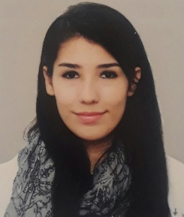
Marianne Dahdah

- Karem Saddeh, Zgharta- North Lebanon
- Mobile: +96171 197653
- E-Mail: dahdahmarianne@gmail.com

Career Objective
Seeking an entry-level position to begin my career in a well reputable organization.

Education
ANTONINE UNIVERSITY, BAABDA
Bachelor of Journalism and Communication at Antoine University, 2019

LEBANESE UNIVERSITY
Pursuing a 3-year bachelor in Political Science.

COLLÈGE DES FRÈRES DE LA SALLE, ZGHARTA

Lebanese Baccalaureate, General Sciences, 2016

Technology
Computer: MS Office (Word, PowerPoint), Adobe Premiere and Photoshop, Adobe after effects.
Languages
Arabic: spoken and written fluently
English: spoken and written fluently
French: spoken and written fluently
Italian: spoken and written fairly
Personal Data
- Former at An-Nahar newspaper (October 2018)
- Member of the retired people committee in Zgharta’s municipality
- Head of the regional north committee of “Pioneers’’(tala2e3 )
- Member and head of Zgharta’s “Virgin Knight” (Foursan Zgharta)
- Member at youth committee of Maronite Eparchy - Tripoli
- Previous secretary at the regional committee of “Pioneers”(Tala2e3)
- Participated in Business Etiquette and Leadership trainings
- Participated in IDF13
- Worked in a Summer Camp “CAPS” (Year 2017)
- Won the second place in a poetry contest (Year 2014)
- Previous member of Vincentian Marian Youth
- Previous member in the Lebanese Red Cross Association
- Participated in the National Youth Day (year 2014)
- Previous active member at the National Youth Day (year 2015)
- Previous volunteer at “Offre Joie”, “Mission de Vie”, “Donner Sans Compter” NGOs
- Previous member at the Youth Committee in Zgharta

REFERENCES AVAILABLE UPON REQUEST

