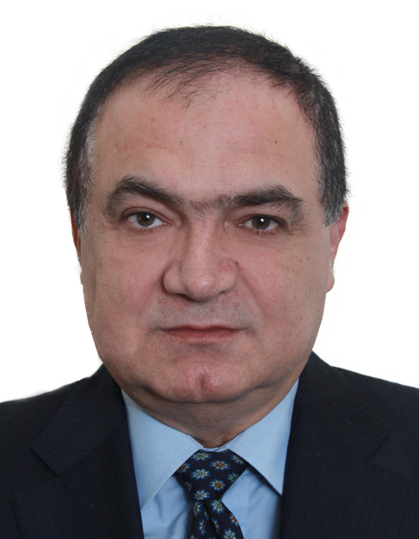
Curriculum Vitae

Business development manager

Personal Data:

Name Rabih Rawass
Date of Birth August 03, 1957
Nationality Lebanese
Religion Christian
Marital Status Single
Address Lebanon Hazmieh, Mar Takla Area
Telephones Mobile 009613-337227 Home 009615-953120 Beirut, Lebanon
E-Mail rabihrawass@hotmail.com; rarawass@yahoo.com;
Hobbies All kind of Sports, Chess, Music, Movies, Internet, Martial Arts

Languages Arabic – English – French (Fluent in Speaking-Reading-Writing)

Diplomas 1- B.A. in “Business Administration – Accounting & Finance” (1977-1981) Lebanese University
2- B.A. in “Laws” (1979-1983 - Lebanese University – Lebanon
3- B.A. in “Insurance & Reinsurance” (1977-1981) U.S.J. University – Lebanon

Certified Courses
- Delivering Excellence Workshop-Customer Services-Qatar Airways
- Time Manager Workshop - Cyprus
- Chartered Insurance Institute courses in Cyprus
- Computer Literacy Certificate: Radio Code Computer Center – Lebanon
- Microsoft Office-PIMS1&2 - Visual Dolphin – Navision – CRM - ISO
- Familiar with all IT & Accounting Software
- Ex-Sworn Lebanese Auditor (Due to travel)
- Excellent and outstanding business corresponding skills in the 3 languages
Valid Driving Licenses
- Lebanese Driving License
- European Driving License

Working Experience:

A - (2012-2018)………Finance Manager.………………. Lebanese Holding Trading & Construction Group….Lebanon
Job Description / Achievments:
- Managing the Accounting & Finance Department
- Implement, Apply & Integrate a new IT Finance Software
- Implement, Apply & Integrate a new CRM software
- Auditing & Controlling the subsidiaries
- Assist the CEO in decision making
- Preparing all accounting and financial analysis such as P&L, Balance Sheet, Rations, Budgets, Feasibility Studies
- Define the strong and weak points in order to increase the turnover and the profit
- Also I was assisting the CEO in the Legal and Administrative matters

B - (2008-2011)……….….Financial Controller ……………………………….A.G.Vision-Construction...............................Nigeria
Job Description / Achievments:
- Managing the Accounting & Finance Departments
- Set up a new chart of accounts and to integrate the same into a new IT Accounting Software and implement same
- Train & Control the staff
- Control all the construction projects in different Nigerian states by comparing the BOQ Vs. Real Costs & Revenues

C - (2003-2007)…………..Financial Controller/General Manager………...........Hydrotrans/Parsons-Industrial…………..Nigeria
Job Description / Achievments:
- In addition to my duties as a Financial Controller, I was assigned also as a General Manager
- Managing & Controlling the whole Company as per ISO standards

D - (2000-2002)…………..Accounting Manager……………………………...….….Al-Mal-Real Estate…….…………….……….....Kuwait
Job Description:
- Managing the Accounting & Finance Departments
- Establish a new Accounting Chart of Accounts for a Real Estate Company
- Set up and integrate the same into a new IT Accounting Software and implement same

E - (1999-2000)…………..Financial Controller...............................................................A.U.G. Insurance Company..................Lebanon
Job Description / Achievments:
- It was a temporary assignment to solve the deficit in cash flows of the company
- Establish, Implement & Apply a new collection policy
- Insure the collection of our dues from our clients and Brokers
- Train our staff especially our brokers and accountants to work as per the new collection policy

F - (1996-1999)…………..Chief Technical & Financial Accountant...................TIIC - Reinsurance Group.........................Cyprus
Job Description / Achievments:
- Managing the Accounting & the Financial Departments
- Assist other Departments by providing them with the necessary financial reports in the Reinsurance Business

G - (1992-1995)………….Administrative Manager………………………......................Saudi Elevators Schindler.............................KSA
Job Description / Achievments:
- Personal assistant to the Chairman
- Managing the Maintenance Department
- Increasing the Turnover of the maintenance department

H- (1979-1992)…………..Chief Accountant…………………………………………….L’Union Nationale Insurance…...….. Lebanon
Job Description / Achievments:
- It was my first carrier
- I started as an insurance trainee in all the insurance departments
- I was assigned as a chief accountant/Finance Manager at the head office and at some affiliated branches

NB: I Can Start Immediately

Rabih Rawass

