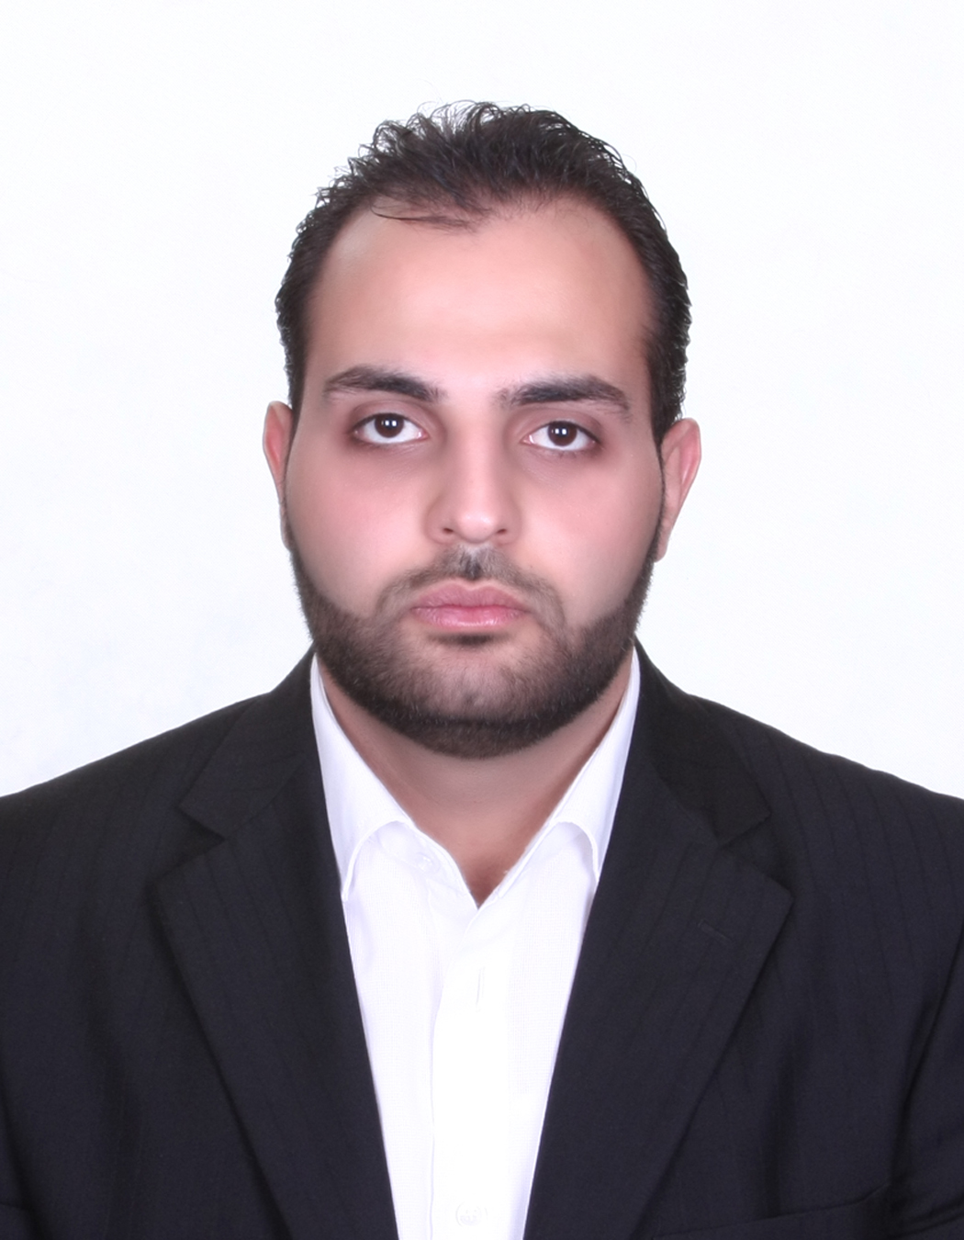
Sayed Elias Ibrahim
Rochdebbin- El-Koura, North Lebanon
Email: sayed.e.ib@hotmail.com
Phone: +961-81-705-134
Phone: +961-6-511-210

Nationality: Lebanese
D.O.B: 24/08/1986
Martial Status: Married

O B J E C T I V E S
- I used to lead 30 persons and about 20 vehicles and was responsible maintaining about 200 sites for 24 hours / seven days per week.
- Abilities to Translate a strategic decisions in a work plan.
- Focus onto maintaining the profit of the company.

E D U C A T I O N
American University Of Technology (AUT) 2012 – 2015
- MBA In Business Administration
American University for Culture &Education (AUCE) 2009-2011

- Bachelor degree BBA major in COMPUTER COMMUNICATION
- Graduated in spring 2011
- Final Year Project establishing a Search Engine

Freddy Atallah Institute - EL Koura(IFA) 2006-2009
TS3 Electronic Grade13.5/20 in Official Exams
Freddy Atallah Institute - EL Koura(IFA) 2003-2006
BT3 Electronic Grade 14/20 in Official Exam

Professional Experience

Carrefour Hypermarket – City mall February 2018 – May 2018
- Senior Supervisor In CCO ( Central cashier officer )
- Responsible for all cash transactions within the store.
- Guarantee strict control and Proper record of all corrections, cancellations, returns and price changes
- Guarantee the quality of services offered to store customers, listen to them & react immediately to their suggestions.
- Ensure the smooth passage of customers in cash registers and the quality of service offered
- Support store GM to measure customers’ satisfaction and guarantee professional image of CCO team

Nini Hospital – North Lebanon January 2017 – November 2017
  - Admission & Invoicing In / Out
  - Cashier

MGR International (Manufacture Global Resource) Equatorial Guinea – Malabo August 2015 – November 2016
- Coordinator Manager, Supports a modern Telecommunication Equipment.
- Reach The Target of reliability.
- Motivate Employees to work in a good Team spirit.
- Responsible for financial issues ( Salary, Buying Equipment, and Employees’ Safety awareness).
- Implementing (PPE) Personal Protective Equipment.
- Search and Improve new Technical Methodology
- Internal Course.
- Create solution to solve the structural challenges.

BUS ( Butec Utility services ) – Mkales August 2013 – August 2015
- Advanced metering infrastructure ( AMI ), all kinds of programing and installing the three meters M3, M4 and M5 using the DLMS Controller and ReadEn 2 DLMS Commander.
- Rehabilitation of substation ( MV, LV )

Chekka Sugar Refinery – Chekka July 2008 – December 2009

- Maintenance of generators, lighting, and power outlets with a team of 10 electricians.
- Sizing and installation of cables, distribution boards.
- Provide lighting and power for temporary use.

Computer Software
- Microsoft office Excel, word, PowerPoint, and Adobe
- VB.net Language. HTML
- C++ Programming Language
- Packet Tracer for Networking configuration
- Linux and Microsoft Windows
- Electronic Workbench
- Motorola 6809 chip programming
- SQL Server

University Projects
- Establishing a Search Engine
- Socket Programming in vb.net
- Network Administration and security
- Firewall
- Implementation of AM/FM modulation on electronic boards
- Evaluation of the usability of internet banking websites in Lebanon (E-Commerce)
- Marketing Management
- Project Management and leadership
- Management information system (MIS)

Languages
- Good in English, French, Arabic and Spanish

Hobbies
Camping, Basketball, Taekwondo, Fishing, and Reading

Reference
Available upon request

