Maroun El Hajj

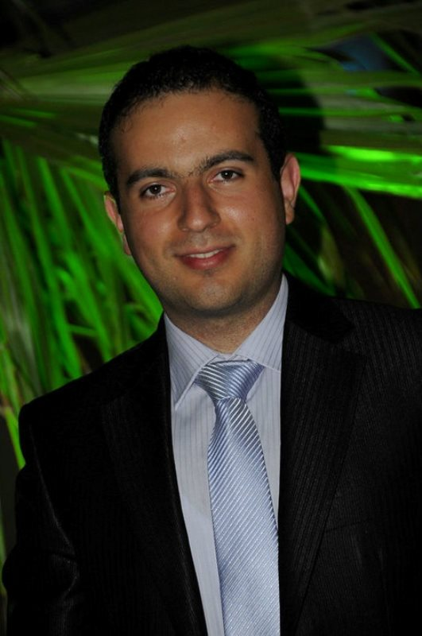

Profile :

Nationality: Lebanese
Date of Birth: 26-4-1988
Marital status: Married.
Current Location: Jal el Dib, Mount Lebanon, Lebanon
Phone No. (Mobile): +961 - 3 - 317197
E-mail: marounelhajj88@gmail.com

Education:

- Higher Diploma in Law from the Lebanese University Faculty of Law -
Section 2 – Jal el Dib - July 2011
- Bachelor degree in law from the Lebanese University Faculty of Law -
Section 2- Jal el Dib - July 2010
- Lebanese Baccalaureate part II-Sociology and Economy branch at Val Pere Jacques
School - Bkennaya - August 2006

Experience:

-June 2018 till present:
Business Development Manager in “Spectapp Real Estate” For virtual Real Estate.(Badaro).
-September 2014 till June 2018:
Property consultant & Sales Manager in Golden land real estate (Jal el Dib)
-May 2014 till 31 august 2014:
real estate agent freelancer at real estate Lebanon/Lebanon links(zalka)
-April 2013 to April 2014:
Full time Job at Khalil Ready Mix Concrete (Harajel Mount-Lebanon)
Sales and Marketing executive assistant/Private
Personal executive assistant of chairman
-November 2011-March 2013:
Full time Job at Elka Group Holding Ready mix concrete (Jeita mount-Lebanon)
Sales Representative indoor/outdoor:
-December2008-Present:
Part time Job in Double Eight productions (Zalka-mount Lebanon) - Event planner and event manager

Languages:

Fluent in Arabic, French, and English

References:

Available upon request.

