PEDRO EL HAJJ

- A Double Major Academic University Student:

- Law.
- Pre-med: Medical Lab.
- Biology.

- Owner & Founder at DON PEDRO

January 10, 2019 to present: El Mansourieh, El Metn, Mount-Lebanon.
- CONSULTANCY
- TUTORING
- TRANSLATING
- TYPING
- TRANSACTIONS
- REAL ESTATE
Office Location: El Mansourieh (El Metn), Lebanon.
Old Main Road, Down Way,
Saydeh Church Street (5/509),
Nassour El Hajj Building (1866),
3rd Floor, East Side Apartment.

E-mail: pedro_elhajj@hotmail.com; pedro.elhajj@gmail.com.
Mobile: +961 76 120 932.
Date of birth: 02 / 05 / 1991.
Place of birth: El Mansourieh, El Metn, Mount-Lebanon.
Living Place: El Mansourieh, El Metn, Mount-Lebanon, Lebanon.
Nationality: Lebanese.

- Studies Law at Lebanese University, Faculty of Law and Political & Administrative Sciences II, Jal El Dib, El Metn, Mount-Lebanon, Lebanon, (2015-Present).

- Studied Pre-med: BS in Medical Laboratory Sciences at University of Balamand, Faculty of Health Sciences FHS, Ashrafieh, Beirut, Lebanon, (2011-2014).

- Studied Biology at Lebanese University, Faculty of Sciences II, El Fanar, El Metn, Mount-Lebanon, Lebanon, (2009-2011).

- Went to Al Akhtal Al Saghir Secondary Official School, Bauchrieh, El Metn, Mount-Lebanon, Lebanon, (2006-2009).
High School diploma in Life Sciences: Lebanese Baccalaureate, 2009.
Classe Terminale: SV (Sciences de la Vie), Bac Libanais, 2009.

- Went to SSCC Ain Najm, El Metn, Mount-Lebanon, Lebanon, or « Collège des Sœurs des Saints-Cœurs, Ain Najm, El Metn, Mont-Liban, Liban » (1994-2006).

In my Lebanese Academic History, I was always an excellent student with the highest marks record. I speak and write English and French fluently, besides Arabic which is my L1 or Native language. As for my L2, it's English and French at the same time since I went through both French and English Systems at Schools and Universities.

I've graduated from High School with a Life Sciences Diploma, where I was at French System Schools, but with an intensive English program provided yearly.

I've done a double major at University. First I've studied Biology at Lebanese University in French System, and then I've transferred to Medical Laboratory Sciences' major at University of Balamand UOB in English American System where I was registered in the Pre-medical track, in order to become a Medical Doctor. There was equivalence at UOB for most of the courses taken in Biology Major at Lebanese University.

Finally, I'm studying Law at Lebanese University in Arabic and English, where most courses are given in Arabic and the rest in English, in order to become a Lawyer, after I’ve totally changed my mind about my lifetime career due to many reasons. I didn’t apply for the BBA test yet.

During my life, I’ve travelled a lot and visited so many places, where I met new people and saw new cultures. Nowadays, I have friends nearly everywhere. Plus, I am always interested in increasing my knowledge in all fields. Besides, I have a huge general culture.

- Owner & Founder at DON PEDRO

My Business Card (Recto/Verso)
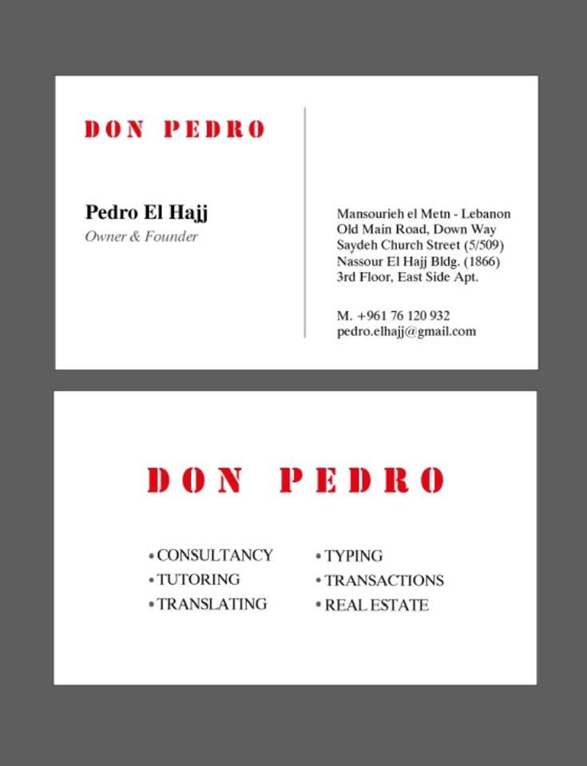
My Business Sign (Recto/Verso)
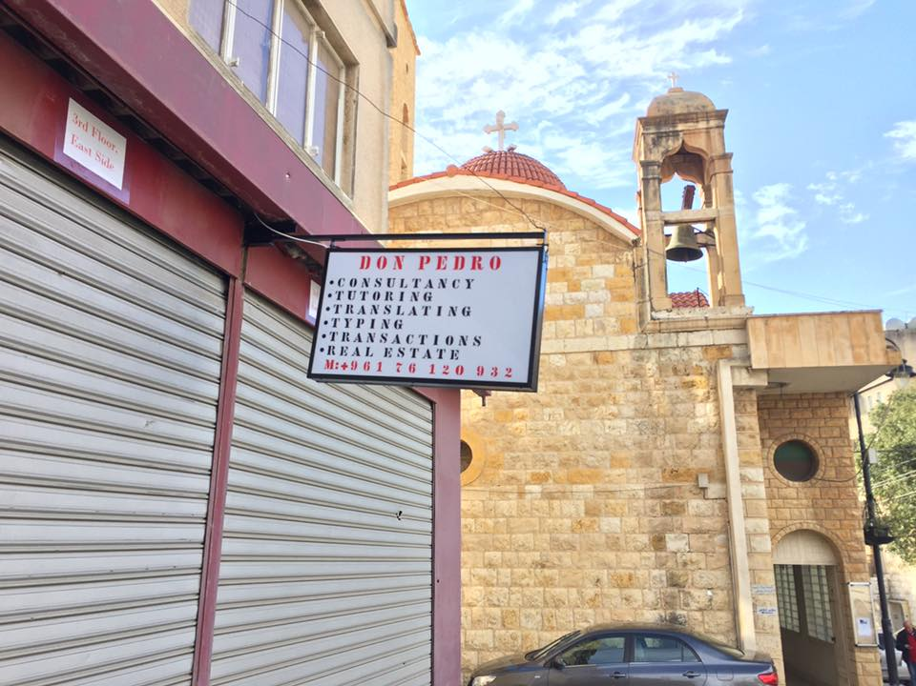

In each of the Six Fields, I have a lifetime experience, especially in Tutoring since I used to give Tutorial Lessons for many students when I was at School and University. I’m so good in legal Transactions too.

In fact, I am so good in any Managerial Position or any Operational Field. I used to run The Family Business with my father on my free times, especially during the summer vacations. Now it has been around five years since I’m running it alone after my father is not able anymore.
Our Family Business is related mostly to General Trading and located in Mansourieh and Moukalles areas, it consists of:

- An Electric Shop in Mansourieh called Nassour Electric Center, and a Tools & Construction Materials Shop besides it. (1978-2016). Ownership.

- Rental of Apartments/ Studios and Lands. (1969- Present). Ownership.

- Olive & Olive Oil business due to owned and rented agriculture lands or estates, alongside general fruits & vegetables. We hire workers. (1927- 2016). Ownership/Rental.

This is why I have a huge experience and knowledge in sales, marketing and advertising. I am a good Sales Consultant and a good Trader with special skills of convincing clients to purchase.

On the other hand, I have a huge experience in the Hospitality and Tourism industry since I’ve travelled a lot in my life and visited so many places, plus I was raised in a house with high levels of hospitality, well known and so popular too in my hometown and further. Being a native in my hometown where I am living at the same time is a great privilege, especially because all my ancestors were living there too long time ago, around 300 years ago, which makes us real old-timers, and the descendants of an old and noble family. This is why I am so good in hospitality, relating to the business of entertaining clients, conference delegates, or other official visitors.

- I am a good Writer, in Arabic, English and French. I write novels, articles, poems, short stories...etc.

- I am an excellent Speaker and Orator, so good in talking and discussing as well as interrogating and investigating. I am also a good speech-maker.

- I am a great Actor, in Action, Drama, Comedy, even Horror. I didn’t appear on Television or Cinema, but at School I used to get the highest marks on Performing and Casting Arts during the Theatre Classes.

- I am a great Imitator, the Art of Imitation has been one of my talents since I was a child.

- I am a good Model for fashion, and I love fashion too, but since I must have a height of at least 186 cm, I wasn’t accepted for modelling, even though I have a 175cm of height.

