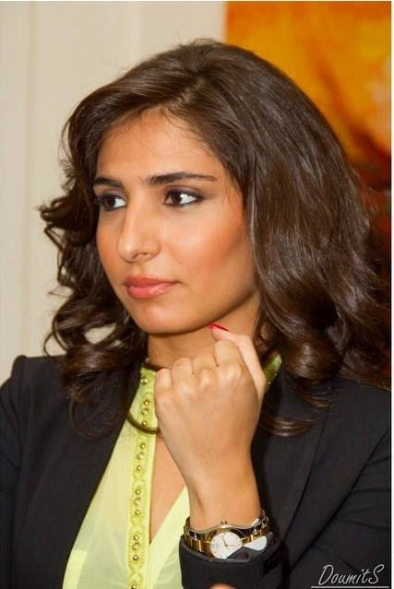
Lana Mamlouk
DOHA , QATAR
Phone: +974 55 78 77 03
E-Mail: lanakmamlouk@gmail.com

Highlights of Qualifications
- Worked for 4 years as a Business Development Manager for a real estate construction company (Greenhill International S.A.R.L) in Lebanon.
- Worked for another 4 years as a Store Manager at Flamant Rose Fashion in Lebanon.
- Five years of experience as an Event Coordinator (Mother’s Day, Christmas, holidays, etc..)
- Trilingual - Able to communicate in Arabic, English and French.

Skills
Excellent administrative, communication and retail management skills.
Team player, self-reliant, energetic and confident.
Rapid adaptability and able to work in a fast-moving environment.
Very good planning & organizational capability.

Experience

Project Coordinator - Stars On Board January 2019 – Present
- Event planning
- Coordinating meetings and appointments at different embassies
- Director and manager assistant during cruise trips
- Stars on Board is an event management company that has been organizing cruise concerts.

Shop Manager - Flamant Rose Fashion August 2013 – December 2018
- Complete store operational requirements by scheduling and assigning employees; following up on work results.
- Maintains store staff by recruiting, selecting, orienting, and training employees.
- Achieves financial objectives by preparing an annual budget
- Formulates pricing policies by reviewing merchandising activities; determining additional needed sales promotion; authorizing clearance sales; studying trends.
- Determines marketing strategy changes by reviewing operating and financial statements and departmental sales records.

Event Coordinator - Flamingo Events March 2012 – March 2017
- Create and present ideas and solutions.
- Plan, budget and organize
- Negotiate to work out prices with clients and contractors.
- Coordinate with suppliers, contractors, employees and staff.
- Maximize networking opportunities and regularly using events to develop a further network of contacts.
- Offered customer service and interpersonal skills.

Business Development Manager - Greenhill International S.A.R.L. July 2009 – June 2013
- Understand and keep up to date with constant developments in the construction industry
- Identified areas for expansion and development
- Developed sales goals for the business and ensuring they are met
- Accounting (Documents financial transactions by entering account information).
- Oversight construction projects Business administration and customer relations.
- Generating leads and efficiently keeping in regular contact with existing clients.

Education

Beirut Arab University September 2005 – June 2009

Bachelor’s Degree in Accounting – Business Administration Faculty

Personal Information
Nationality: Lebanese
Date of Birth: February 25th , 1987.
Place of Birth: Lebanon.
Marital Status: Single.

