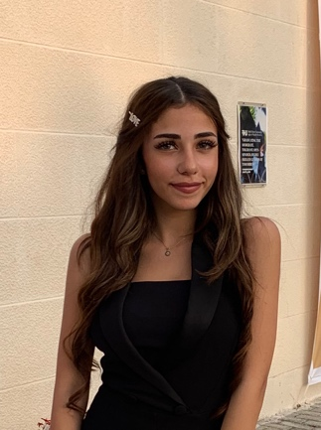

Lama Mohamad Al Deeb
Phone Number: +961 81714934
Email Address: lamaaldeeb16@gmail.com
Nationality: Egyptian
Area of Residence: Lebanon

OBJECTIVE
An ambitious IT management undergraduate student seeking an internship. Having me at your company will help me gain more knowledge and experience in my domain. Throughout your guidance, and support I will be capable of dedicating my effort, passion and ambition, towards achieving your company's goals and objectives.

EDUCATION
2016-Present Rafik Hariri University Mechref, Lebanon
Senior
IT Management
GPA: 84
2007-2016 Education International School Riyadh, Saudi Arabia American Diploma

RELATED COURSES/PROJECTS

Database Management System Course:
Project: BookMyTable - a restaurant reservation application was developed to help ease the use for both clients and restaurants. In addition, to save time and effort.

Project Management Course:
Project: Apple Inc. Introducing a New Product- a research and business plan done to study the factors related to the introduction of smart home appliances in Apple Inc.

Software Engineering Course:
Project: UML diagram and architecture design model were done for the BookMyTable application in the database management systems course.

Web Programming Course:
Project: A hotel website was developed that provides the user with information they need in addition with the facility to book a room.

Networking Course:
Enables students to gain fundamental knowledge of computer networks, learn to design and analyze protocols.

SKILLS
- Computer Skills: Microsoft: Word, Excel, PowerPoint, Access, Visio, Project, Visual Studio
- Programming Language: C++, JavaScript, Html, SQL
- Communication and Interpersonal Skills: ability to work efficiently with team members, under pressure, and manage multitasking
- Researching and Documentation: ability to work on projects and researches
- Project Scheduling: ability to finish within the deadlines and to supervise and lead group of colleagues
- Fast Learner
- Presentation Skills
- Critical Thinking Skills: ability to analyze, solve problems and provide the most suitable solutions.

AWARDS
- Dean’s honor list with GPA 85.88 (Spring 2018)

EXTRACURRICULAR
- Attended workshop “Personal Branding 101: How to Market Yourself” at RHU
- Community Engagement: Volunteered for a month in the orphanage center in Khaldeh
LANGUAGE
Arabic (Mother Language) Fluent in writing, communicating and speaking
English (Second Language) Fluent in writing, communicating and speaking

REFERENCES
Available Upon Requests

