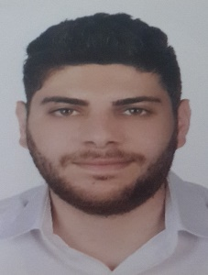
MAHER ABOU JAOUDE
Graphic Designer

Personal Information
- Full Name: Maher Abou Jaoude
- Date & Place of Birth: 11 February 1994, Jal el Dib, Lebanon
- Nationality: Lebanese
- Email Address: Maher.aj18@Gmail.com
- Address: Abou Jaoude building, Bkenaya Main road
- Mobile: +961 70/405561
Education
September 2017 – Present: University of the Holy Spirit Kaslik (USEK)
Kaslik, Lebanon
Major: Graphic Design

October 2012-May 2016: University of the Holy Spirit Kaslik (USEK)
Kaslik, Lebanon
Bachelor in Business Administration
Major: Business Computing

April 2012: Val Père Jacques, Bkenaya
French Baccalaureate
Experiences
February 2016 – July 2017: Software Developer at DIGISYS; Sin El Fil, Lebanon
- Wrote applications and implemented new features on existing ones
- Supported the company’s clients in resolving issues in the application
September 2017 – February 2018: Sales at MALIKS, Lebanon
- Provided customer service and assistance for all customers of the branch
- Cashier and also printing
June 2018 – September 2018 Sales Executive at Empire, Sodeco, Lebanon
- Data entry
- Data Analysis on newly released movies

March 2019 – April 2019 Graphic Design Internship at KOOK studios, Jounieh, Lebanon
- Worked on Logos and posters
- Assisted the design team as needed

Skills
Computer Skills:
Software: Illustrator, Photoshop, After Effects, InDesign, Adobe Premier, Adobe XD, 3ds Max, Word, Excel, Power point, Access
Programing languages: VB.net, Crystal Reports, HTML, CSS, JavaScript, SQL and ASP.net

Language Skills: Speaking Writing Reading
Arabic Excellent Excellent Excellent
English Very good Very good Very good
French Very good Very good Very good

