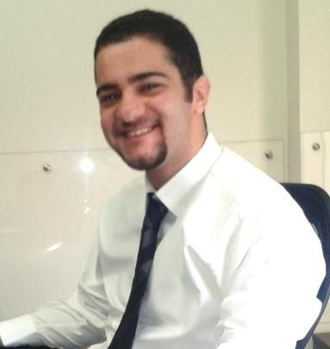
Maroun Andre Al Ammar

Contact Details:

Address: Beit Mery – Al Shaghour, Lebanon
Date of birth: June 25, 1991
Place of birth: Beirut, Lebanon
Mobile Number: 961 3 066894
E-mail: maroun.ammar@live.com

Career Objective:

Seeking a position in the Information Technology Department of a reputable organization.

Education:

June 2013: B.S in MIS (Management Information Systems) at
AUST (American University of Science & Technology) – Achrafieh

- Notable Courses Taken: Senior Project in MIS, Enterprise Systems, Database Management Systems, Project Management, Systems Analysis & Design, Operations Management

June 2009: BT3 Sales & Commercial Activities
Byblos Institute - Dora

June 2008: BT1-BT2 Accounting & Computer
Montana Institute of Technology & Applied Sciences – Deek El Mehdi

June 2006: Saint Joseph School (Cornet Chahwan)

Certificates:

CCNA 1 Networking Basics
CCNA 2 Routers and Routing Basics
Certificate of Proficiency in English as a Second Language – The University of Michigan

Professional Experience:

June – July 2012: IT Trainee – First National Bank

March – October 2014: Technical Consultant: Trainee – Omnisoft Services

May – August 2015: IT Trainee and Support – BankMed

March – November 2017: Freelancer – La Revue Diplomatique

April – May 2018: IT Intern – Holdal Abou Adal Group

Main duties:

- Holdal Abou Adal Group:

  - Learned Microsoft Dynamics AX 2012 Retail POS basics and installation
  - Microsoft Dynamics AX 2012 ERP basics
  - IT Support activities

- La Revue Diplomatique:

  - Preparing Invoices and Receipts
  - Sending emails to clients
  - Solving IT-related problems

- Bankmed:

  - End user support:
    - User Accounts, Remote Assistance, Hardware and Software Installation, Network Patching, Printers, Scanners, Telephones, Operating System Deployment and Configuration, Troubleshooting

    - Upgraded and replaced the computers and servers of several Bankmed branches across Lebanon (Raouche, Hazmieh, Corniche El Mazraa, Khaldeh, Foch, Beirut Souks)

    - Trained in the Information Technology Department (Clemenceau and Verdun Head Offices)
- Omnisoft:

  - Worked on three IBM Solutions: Endpoint Manager, Worklight Foundation (now MobileFirst Platform), Tivoli Netcool Omnibus

  - Experience and knowledge (from both the technical and business perspective) in the above mentioned systems, as well as their installation and implementation

  - VMware infrastructure: creating and configuring virtual machines

- First National Bank:

  - Worked on creating a Java program which retrieves data from the AS/400 System utilized by the Information Technology Department.
The skills I have acquired constitute of the following:
    - Basic commands and functions of the AS/400 system
    - Web services application overview
    - Using Java to access the AS/400
    - Overview of the four networking aspects: IP Telephony, Routing and Switching, ATM, Security

Computer Skills:

- Programming Languages: C++, Java, and SQL (Oracle)
- Microsoft Office: Project, Access, Word, Excel, PowerPoint, Outlook
- Operating Systems: Windows XP, Vista, 7, 8, 10 ; Linux
- Operating system deployment and configuration
- Hardware and software installation
- Troubleshooting
- Eclipse IDE
- HTML
- Mobile phone simulation (Blackberry 10 Simulator, Android Virtual Device Manager)

Languages:

Arabic: Native, Spoken & Written
English: Excellent, Spoken & Written
French: Fair, Spoken & Written

Hobbies:

Sports (Swimming, Basketball, Football…)
Music (Guitar, Song-Writing…)
Reading (Novels, Poetry, Informative books…)

