 | Kassem Shahine
Public Relations
Digital Communication
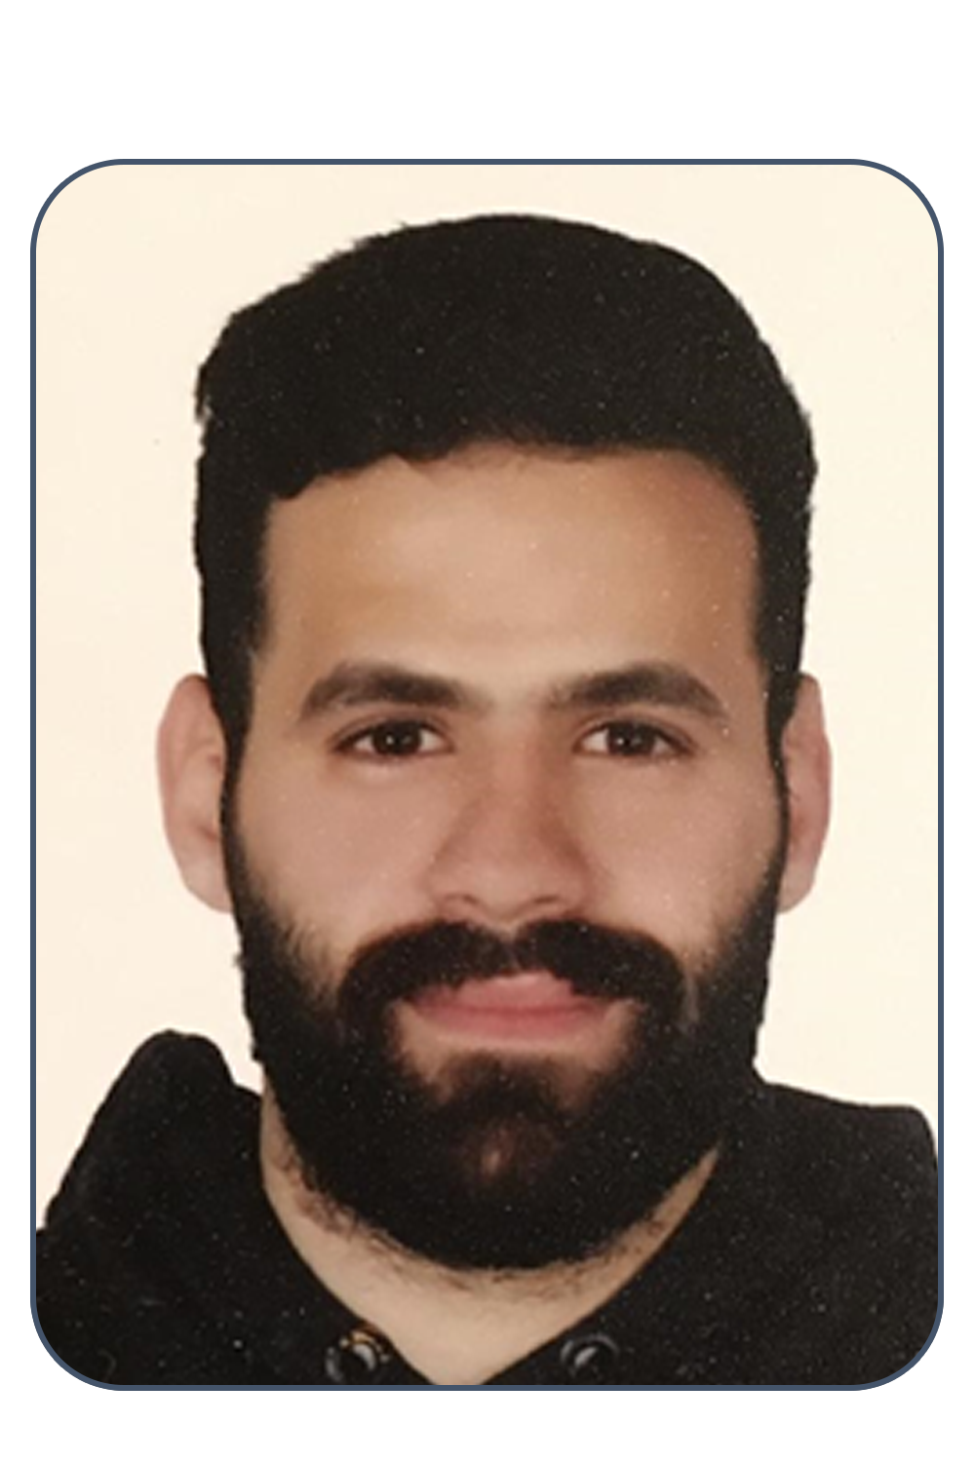 | Lebanon | Beirut  phone | +961 70890849  e-mail | kassemshahine95@gmail.com  DOB | 21 March 1995

CarEEr objective

Seeking a job in the field of public relations and digital media, where I can build a professional career, express my strong academic ideas, and develop my experience.
A job where I can apply the communication skills and all the knowledge that I have learned in this field.

Education
2019 – Current Lebanese University, Faculty of Infomation Tayouneh - Lebanon
Master 2 in Digital Media

2018 – 2019 Lebanese University, Faculty of Information Unesco - Lebanon
Master 1 in Corporate Communication

2013 – 2018 Lebanese University, Faculty of Information Unesco - Lebanon
Section 1 - Bachelor in Public Relations

2010 – 2013 Al Mostafa School Haret Hreit - Lebanon
Lebanese Baccalaureate - Sociology and Economics

Internship
January 2019
Organization of the Arab Economic Summit
Internship under the supervision of the vice director.
Tasks and Responsibilities
- Responsible for Mass Media Marketing Strategy including social media
- PR management
- Events planning

August – September 2019
Azadea Company
- Training at in the events department

Professional Experience
- Organize conferences with the World Health Organization.
June 2018 => August 2019
- Photographer and member of the media committee of Al-Ahed Club.
January 2017 => Current day
- Responsible of public relations, social media and photography at Roda Antar Football Academy. June 2018 => Current day
- Participate in organizing the opening of the West Asian football federation Championship 2019 in Iraq.
Under the supervision of LMS Sports and the Iraqi Ministry of Sports.
- Participate with Al-Ahed Club as a media committee in the Asian Cup in Malaysia Kuala Lumpur. AFC Cup champion with Al Ahed Club.
- Digital marketer specializing in creating SEO with experience executing social media strategies.
Search engine optimization for “Khoury Home” Website.
- The owner of the campaign idea: أنا حد بلدي . Responsible for 100 volunteers and social media.

PeRsonnal Qualifications
- Excellent communication and writing skills
- Ability to multitask and meet deadlines
- Adapts easily to new situations
- Ability to work within a team-based environment
- Good listener and analyst, problems solver
- Quick learner

Certifcates
- Certified in the Fundamentals of Digital marketing - Google.

Computer Skills
- Excellent commend of Microsoft Word, Excel and Power Point, Montage.

Language skills:
- Arabic: Mother Tongue
- French
- English

Interests:
Leisure & Sports:
- Professional Football Player
- Professional Photographer
References:

- Available upon request

