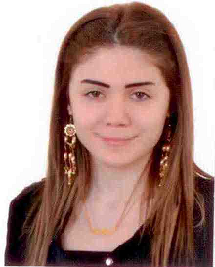
- Rana Ahmad Safa
- 00961-76-680473
- Lebanon, Beirut, Burj Al Barajneh, Khodor al Harakeh Street
Rana_Safa_1991@outlook.com

Objectives

Seeking a position that will offer opportunities to improve knowledge in aspects of sales, marketing, and computer science field.

Education

2015 – 2018 American University of Culture and Education Beirut- Lebanon
School of Art and Sciences – Computer Science

2013 – 2014 Al- Maarefa High School Beirut- Lebanon
Baccalaureate in Sociology and Economics

Work Experience

January 2017 – Present Time
Smart Source/ Citrus TV – Achrafieh Lebanon
- Whats app Sales
High Conversion ratio
High Quality
Full Attendance
- Live Chat
- Email ( Support )
- Sales agent ( Inbound)

October 2014 – November 2015
Salon Ramzi & Hanane - Beirut Lebanon
- Cashier
- Take appointments
- Close balance (end of day/ end of month)

June 2010 – September 2014
Rahhal Optic - Beirut Lebanon
- Saleswoman

Skills

- Having excellent communication and interpersonal skills
- Working independently and with teams
- Organize material and information
- Familiar with Microsoft office – SAP – Magento

Hobbies :

Music and sports

Languages

Fluent in English, Arabic

References :

Available Upon Request

