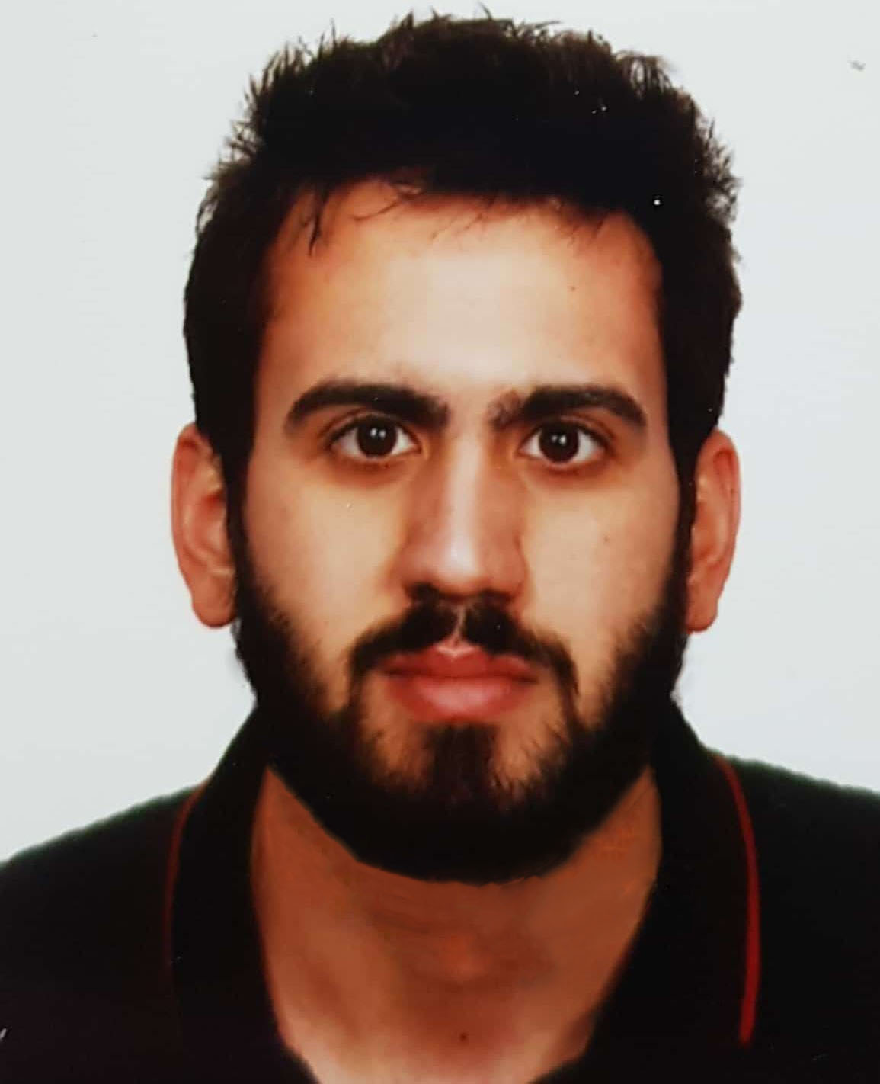

Hady Halawy
Address: Sainte Thérèse. Lebanon. Mobile: +961 (76) 760 477.
Nationality: Lebanese. Date of birth: March 31st, 1994. Email: hady.halawy@gmail.com.
Marital status: Single.

PROFESSIONAL EXPERIENCE

2019 – Present:
KIDZMONDO, Downtown
- IT Officer: Administering Microsoft Dynamics NAV, Active Directory, SQL Databases, Avaya Telephony and various systems/apps built specifically for the company.
Providing technical support across the company (in person or over the phone). Repairing and replacing equipment as necessary.
Installing CCTV System (Dahua) and maintaining their proper functioning.
Writing queries and retrieving data from the database.
Liaising with providers to check prices for procurement of new equipment.
Establishing good relationships with all departments and colleagues.
Doing the final work report.

2016-2019:
THE GREEN PACT, Sodeco
- Administrative Officer and IT: handling all tasks related to logistics and delivering a wide range of support and administrative functions. liaising with customers in a service-oriented manner on behalf of Green Pact by providing phone services and welcoming visitors.
Managing and coordinating the meeting room. Handling orders for food, drinks, office materials and kitchen supplies. Coordinating and supervising the cleaning staff. Taking minutes of meetings.
Doing the office inventory by modifying it on the system and updating the stickers on the physical items.
Procurement Support. Handling all IT related matters and performing any other duties and tasks at the request of the management (Excel, Word, PowerPoint).

2015 - 2016
MCIC (ISTIKBAL, BELLONA AND CONSTRUCTION), Mcharafieh
- IT Technician: Installing and configuring hardware and software components to ensure usability. Setting up and maintaining CCTV and VOIP systems.
Upgrading the entire system to enable compatible software on all computers. Installing and upgrading anti-virus software to ensure security at the user level. Providing support to users and being the first point of contact for error reporting. Managing network and firewall.
Handing on networking installation in different sites. Supporting and guiding users. Managing technical documentation.

EDUCATION

2015 - 2019: Lebanese International University, Salim Sleim, Lebanon.
➢ Bachelor’s degree in Computer Engineering.

2007- 2008: Collège Notre Dame du Perpetuel Secours, Furn El Chebbak Lebanon.
➢ Lebanese baccalaureate in Life Science.

LANGUAGES & COMPUTER SKILLS

➢ Languages: Arabic (fluent), English (fluent), and French (Advanced).

➢ Computer Skills:
- Office 365.
- Internet use.
- Microsoft Server OS (2008-2012-2016).
- DNS and DHCP.
- File sharing.
- SQL (Postgres, Microsoft SQL and NAVICAT 11).
- Networking.
- Exchange Server (2010,2016).
- Microsoft Azure Active Directory.
- VOIP (Grand stream, Avaya).
- VPN (PPTP-L2TP).
- MIKROTIK OS.
- Documentation and monitoring
- Linux (Ubuntu), MacOS (Mojave).
- Firewall.
- Active directory.
- Group Policy implementation.
- Hyper-V and server virtualization.
- VMware ESXI.
- NAS and raid solutions.
- Cisco OS
- JAVA, HTML, C++, JavaScript.
- CCTV Installation.
- Problem solving.
- Networking hardware and cabinets installation.

REFERENCES

KIDZMONDO:
Pierre Ghorra: IT Manager.
Telephone Number: 03-193 619.
Email: Pierre.g@kidzmondo.com
THE GREEN PACT:
Jennifer Khoury: Human Resources.
Telephone Number: 03-153 405.
Email: Jennifer.Greenpact@gmail.com.

MCIC:
Widad Kassar: Human Resources.
Telephone Number: 81-605 444.
Email: Widad.k@gmail.com.

.

