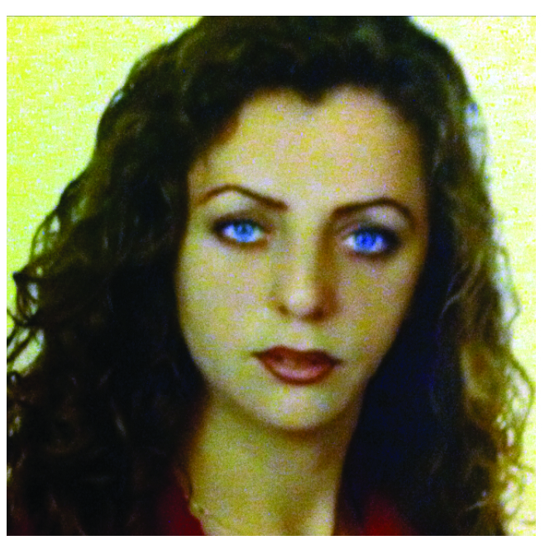
CURRICULUM VITAE

Full Name : Jouhaina Zahr
Date of Birth : 26/9/1972
Gender : Female
Nationality : Lebanese
Address : Hadath, AL American Street, Ahlam Building, 2nd Floor.
Telephone (Home) : 05/463817
(Mobile) : 03/840426
E-mail : Jouhaina.zahr1@gmail.com
jogunda-2012@hotmail.com

Education

- Bt3 in "Programming" Official Certificate from CIS Institute Beirut, Lebanon
- Baccalaureate 3 rd in Nour El Alliah
- Special Courses in Typing and Computers

Work Experience

- Inaash Bank 5 years (Secretary Of General Manager)
- Airport 2 years (Grand Hostess )
- Port Of Beirut, Beirut Container Consortium Company from
2005 till 2015 (Different Administrative Departments)
- Mechanic Lebanon (Inspection) From 2016 – 2017 (Cashier).

Skills

- Good skills in reading, writing and Speaking English, Arabic
- Not Bad In French
- Good Experience, Competency and Knowledge in Office Tools (Ms Office, Windows, Word, Excel, Access Outlook, Social Worker and Internet)

Hobbies
Reading, Swimming and Walking

