Aya Sharaf
Email: aya-sharaf@live.com
Mobile: +961 70 617 856
Single, Lebanese

A motivated graduate with a master’s degree in conference translation at USJ who is eager to utilize and enhance her personal and professional skills in the job market.

Professional Experience

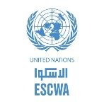 ESCWA (INTERNSHIP) - BEIRUT, LEBANON
- translating publications and documents from English into Arabic.
- Editing Arabic documents
- writing precis-writings August-October
 GEEKEXPRESS (INTERNSHIP) - Beirut, Lebanon
- Translating GEEKEXPRESS’ website from English into Arabic
- Translating emails and brochures into English July & August

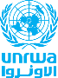 UNRWA (Internship) – Beirut, Lebanon. March & April 2019.
- Translating Documents (Arabic into English, English into Arabic).
- Editing English Reports.
- Translating news articles/confidential documents.
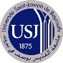 USJ workshop – Saint Joseph University of Beirut, Lebanon. August 2017.
In depth learning of how one should teach the Arabic Language for foreigners.

Alameh translation & Services (Internship) – Beirut, Lebanon. 2016-2017
- Translating Documents (Arabic into English, English into Arabic, French into Arabic, Arabic into French).
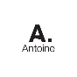 Librairie Antoine – Beirut, Lebanon. 2016.
- Sales Department.

Ditto Translation Agency – Beirut, Lebanon. 2012.
- Translating Documents (Arabic into English, English into Arabic, French into Arabic, Arabic into French).
Education
Master’s Degree in Translation (Conference Translation), Saint Joseph University of Beirut, Lebanon. 2019.
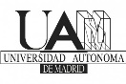 Spent a semester in Madrid, Spain at Universidad Autónoma de Madrid.
Bachelor’s Degree in Translation, Saint Joseph University of Beirut, Lebanon. 2017.
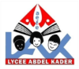French Baccalaureate Certificate (ES) – Lycée Abed El Kader, Beirut, Lebanon (Graduated with honors). 2014.
Languages & Computer Skills
Languages – Arabic, English, French & Spanish.
Computer Skills – Word, Excel, PowerPoint, WordPress.
Activities & Hobbies – Tutoring, Singing, Reading, watching movies, swimming.

