Email 1: Job Seekers (already part of the database)
SUBJECT: Join our Community & Work Happy!
Hello!
Searching for job opportunities on the BDD platform is now easier with our new portal. Create your new profile and apply to the different vacancies available within several companies at Beirut Digital District.
Couldn’t find your desired position? Create a job alert with your preferred field and get notified once new vacancies matching your qualifications are posted!
You can even login with LinkedIn, Facebook, and several other platforms.
If you have any questions or feedback regarding the platform, kindly contact our HR Team who would be happy to assist you. (to hyperlink HR@beirutdigitaldistrict.com).
We offer careers, not just jobs, that make a difference in people’s lives!
The Beirut Digital District Team.
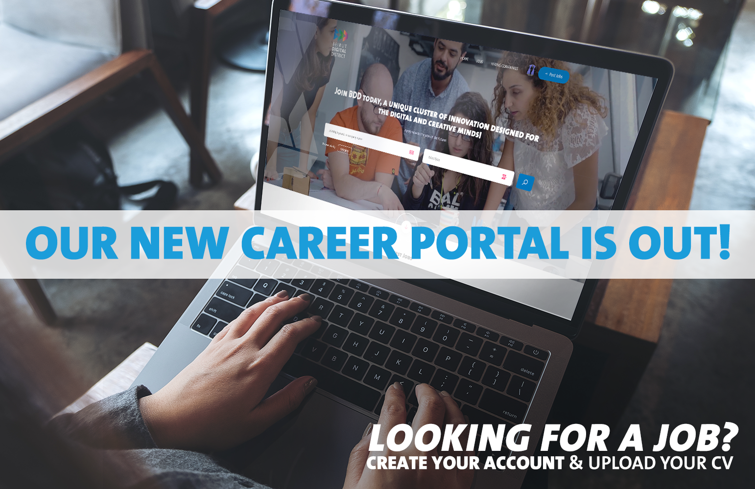

Email 2: Extended Community
SUBJECT: Join our Community & Work Happy
Hello!
Are you a committed, passionate, and motivated talent? Check our Career Opportunities available on our new platform here! (hyperlink: careers.beirutdigitaldistrict.com)
Create your profile, search for a job easily, manage your applications and receive job alerts! You can even login with LinkedIn, Facebook and other platforms.
If you have any questions or feedback regarding the platform, kindly contact our HR Team who would be happy to assist you. (to hyperlink HR@beirutdigitaldistrict.com).
Let your ideas shape the future, and join BDD today!

The Beirut Digital District Team.

Email 3: Community – HR reps
SUBJECT: Check out our new Career Portal & Upload your Vacancies!
Hello!
We are proud to announce that our new Career Portal is now live! Discover new features that include:
- Employer dashboard
- Confidential posting
- Applicant tracking
- Enhanced employer profile
- Candidate search by profiles & resumes
If you already had a profile, kindly make sure to visit careers.beirutdigitaldistrict.com and follow the below steps:
- Login as an employer with your previous email used
- Click on forgot password
- Follow the steps to retrieve your account with all the data imported
- Kindly make sure to double check all company details listed, and update your profile if need be
If you have any questions or feedback regarding the platform, kindly contact Rawan from the HR Team, on rawan@beirutdigitaldistrict.com. She would be happy to assist you!
If you don’t already have an account, we encourage you to create a company profile in order to gain access to all our new features.
Thank you for helping Lebanon rise again, one job at a time!
The Beirut Digital District Team
