Hussein A. Issa  01 May 1993  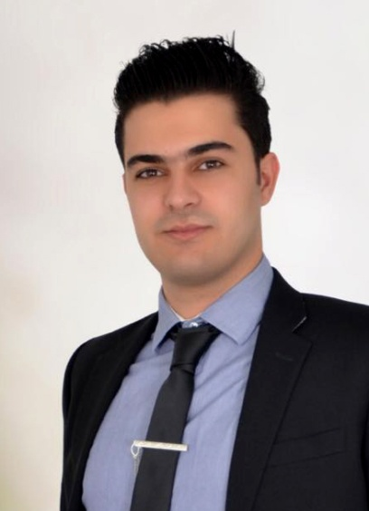  CONTACT  Address:  Sidon, South Lebanon  Phone:  +961 70633931  Email:  husseinissa.eng@gmail.com  LANGUAGES  English (Fluent)  Arabic (Native)  French (Good)  Russian (excellent ) |  | Summary  Seeking a position as a Web Developer where I could apply my skills and knowledge  WORK EXPERIENCE  06/2011 – 04/2012  Car mechanical, Issa Motors car maintenance. , Mousaileh Lebanon  Responsibilities:  - Car mechanical and electrical.  - Diagnosis and maintenance.  - Costumer care.  09/2018 – Present  Automation Engineer, Lebanese Weavers CO. , Zefta Lebanon  Responsibilities:  - Lead a team of 5 carpet machines.  - Maintain timely and accurate oral and written technical data reports regarding activities.  - Distribution and control of workers.  - Programming and coding schedules and data for machines.  - Giving order of productions.  06/2019 – Present  Freelancer, website developer:  - Working with Wordpress.  - Friendly designs and responsive themes.  EDUCATION  2009 - 2011  BT in Car Mechanics  Islamic Technical Institute, Beirut Lebanon  2012 - 2015  Bachelor in System Engineering – Computer systems  Kharkov National Automobile and Highway University, Kharkov Ukraine 2016 - 2018  Master in Automation and computer integrated technology  Kharkov National Automobile and Highway University, Kharkov Ukraine  SKILLS  - Excellent communication and presentation skills  - Machine learning and computer information technologies expert  - Ability to work well in a team, create a friendly atmosphere  - Punctual, resilient, empathetic and adaptable  - Programming and Robotics skills  - Electrical and Electronic skills  - Car mechanical skills  - Good communication - written and oral skills  - Excellent conceptual and analytical skills  - Effective interpersonal skills  SOFTWARE SKILLS  - Microsoft visual studio C#, C++  - Database MS access & SQL  - Wordpress web platform  - Web Development (HTML, SCC)  - PHP Basics  - Java Basics  - Arduino C  - SCADA & PLC  - Microsoft Office  Certifications  - Graduated in the second place in Lebanese technical exams (BT).  - Certified as best foreign student in university 2016 in Kharkov Ukraine.  - Certified in many conferences intra-university.  - Winner the third place in all-Ukrainian student's competition in robotics.  - Holding a certificate of honor from the International Program considered one of the best 50 creative people developed in the Arab world and the Middle East.

