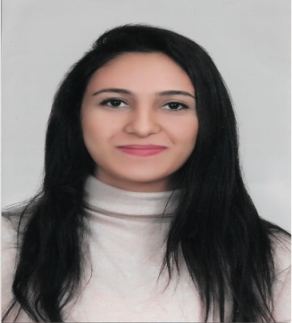
Zeina Kaouk
Beirut, Lebanon
DOB: 14 September 1998
E-mail: zeina.kaouk1@gmail.com
www.linkedin.com/in/zeina-kaouk
Mobile: 0096170602215

American Society of Civil Engineers (ASCE) Member
Summary
Civil Engineering senior student, seeking a position where I can put my knowledge and skills to immediate use, and contribute to an organization’s success.

Professional Experience

Teleperformance Company July/2017 – October/2018

Call Center Agent at Touch - Mobile Telecommunication Company
- Manage large amounts of inbound and outbound calls in a timely manner.
- Follow communication “scripts” when handling different topics.
- Identify customers’ needs, clarify information, research every issue and provide solutions and/or alternatives.
- Seize opportunities to up-sell products when they arise.
Internship

Al Bani Real Estate Development June 10/2019 – July 27/2019
City Towers Site – Haret Hreik
- Apply civil engineer checks regarding slabs, columns and other structural elements.
- Calculate the price of steel, concrete and cable orders for structural elements.
- Attend 3PE Lab to observe tests applied to concrete, steel and soil.

Education

Civil Engineering, ABET Accredited August/2016 - present
Beirut Arab University FIBAA Accredited Debbieh Campus, Lebanon

Skills & Knowledge

- Microsoft Office  - AutoCAD  - Robot for Engineering  - Microsoft Visual C++  - Excellent knowledge of internet use | - Innovative  - Critical thinker  - Problem solver  - Emotionally intelligent  - Highly attentive to details

Training & Certificate

- Google Analyst Certified- Google Analytics Academy
- Inbound Marketing Certified- HubSpot
- Inbound Sales Certified- HubSpot
- Customer Service Training
- Call Center “Employee of the month”
- Going Digital In-house Training

Languages

Arabic- Mother Tongue
English- Fluent

