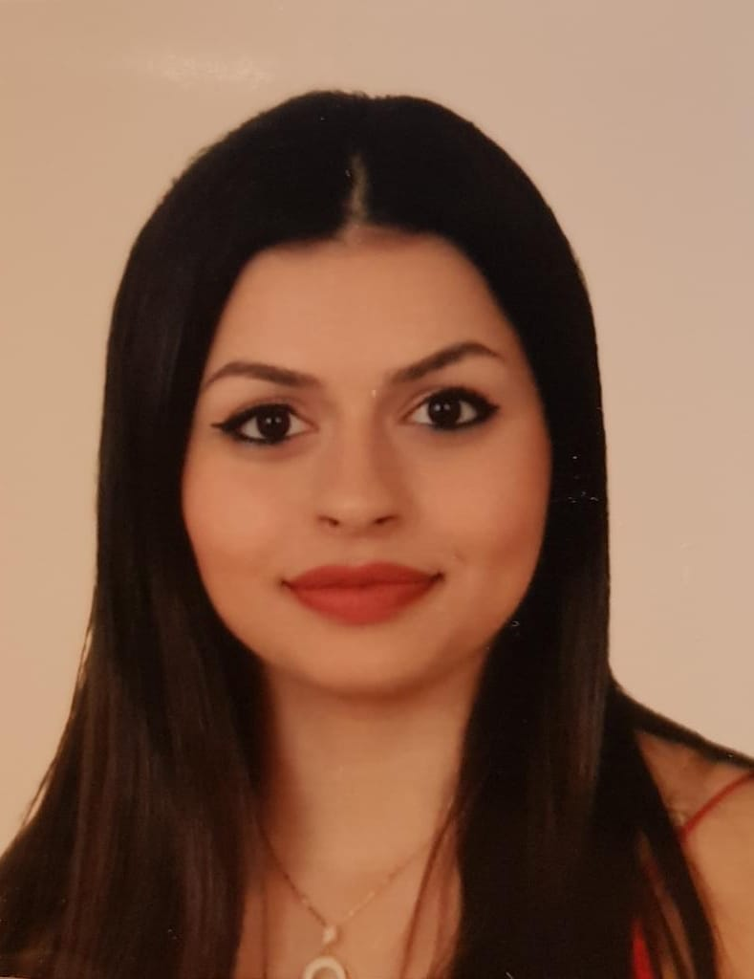 |  |  |  | Vinane Nadar  Date of birth: 12-02-1998

Experience
2016 - 2017
Audit• Al Ahmad Fish Trading Company (by Moussa Nadar)
June 2018 - August 2018
Internship • Internship program at bank Audi (Riad-Soloh branch, Saida)
August 2018 - 2020
NOVO Bank Audi (Part time job)
- Helping people with their transactions and operations on ITMs << interactive teller machine >>
- Open all types of bank accounts in an advisory room.
- Give all types of advices and solutions in any banking problem.
January 2020 – february 2020
- One month of working on bird, the accounting program (with multiple cases and companies)

May 2020 – July 2020
- Sales and Call center agent at Qtrade fx company (nabatieh branch )

Education
Collège notre dame des sœurs salvatorienne MSA, Saida, Abra - Lebanon
(2001-2016)

Saint-joseph University (Saida campus) 2016 - 2019
Diploma in Business Administration (Gestion et management)

Certificate of achievement in accounting level 1 and 2 ( at practical accounting academy )

Skills
- IT: Microsoft Office (Word, Excel, PowerPoint, Access), Windows NT, Internet surfing & Social Media.
- Sociable and able to communicate with all kind of client, and to work in group and under pressure
- Languages: Arabic, Fluently in English, Excellent French
- Trained on Bird accounting software ( data entry , sales , purchase , capital , assets ….)

Activities
- Writing: three English theater plays
- Writing: One book of multiple Arabic stories
- Secourisme (First Aid): Red Cross
- Volunteer at USJ
- Participating in Bank Audi Interns’ CSR day with ETI Life Skills program at AUB

References
- Chantal Mansour [ coordinator MSA school]
- Dr. Ali Fayad [ professor at USJ - Saida campus]
- Ali Khalife [senior teller Bank Audi 70/825436]
- Hoda Santina [ pre-president at Bank Audi - Riad Soloh branch]
Salhiye
Saida – Lebanon
 |  | 70711317
 |  | Vinane.nadar@hotmail .com

