Contact
Address:
Doha el hoss

Phone:
+9617133421

Email:
KarimKoubiassy@gmail.com

Languages
English - Fluent
Arabic - Fluent
French - Fair
Karim Ali Koubaissy

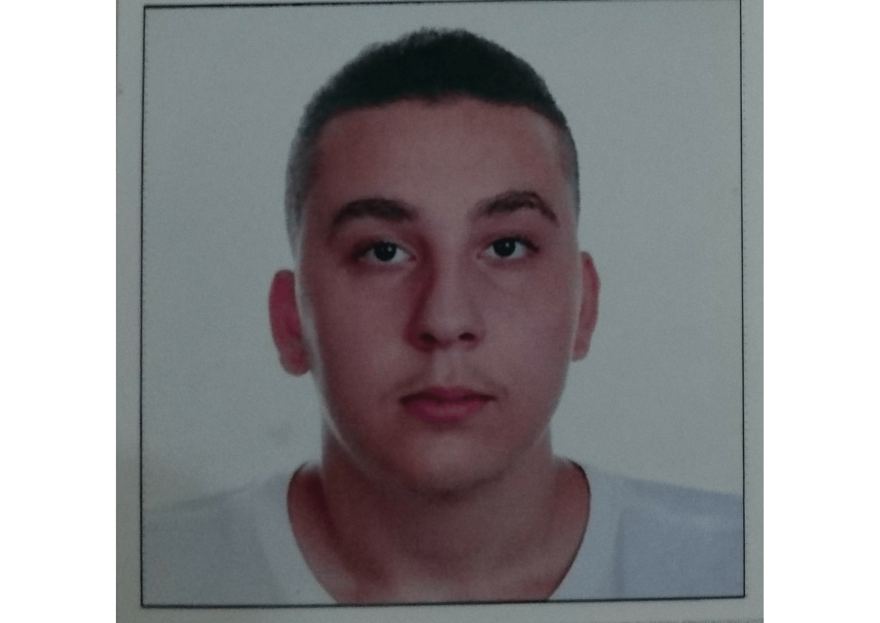

Summary
I am ambitious and driven. I thrive on challenge and constantly set goals for myself, so I have something to strive toward. I’m not comfortable with settling, and I’m always looking for an opportunity to do better and achieve greatness.

Skill Highlights
- An honors student with a record of academic and extracurricular success  - Extensive leadership experience, particularly within a higher education setting  - Adept at working across departments, with faculty, administrators, and students | - Award-winning written communication skills

Education
BS in Marketing – Lebanese International University – Present – Cumulative GPA: 3.60
Al Noor International School: High School Diploma
Cumulative GPA: 4
Graduated: April 2018

Certifications
- Microsoft office
- Introduction To Adobe (Photoshop, Flash)

