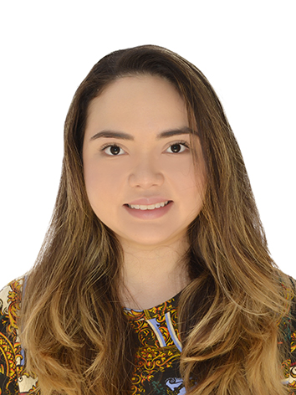

MARIA DEL CARMEN DE LA CRUZ TRABOULSI

Nationality: Lebanese – Colombian. | Cell Phone: +96176758229
 | E- mail:marydt716@gmail.com

EDUCATION
Universidad Internacional de la Rioja, Logroño, Spain.  - E - Master in International Business  Universidad Javeriana. Bogota, Colombia  - Diploma in Immigration Proceedings | October 2019 – Present  June 2014
Universidad Del Norte, Barranquilla, Colombia  - Bachelor of International Relations | September 2012
Universidad Del Norte and Partners of The Americas Barranquilla, Colombia  - Diploma in Leadership | December 2010

PROFESSIONAL EXPERIENCE
E-Intern at Schneider Electric, Barcelona, España.  - Create a strategy of employer branding.  Management Advisor, D&G Barranquilla, Colombia  - Organizing administrative functions to ensure that the D&G Solutions’ international relations activities are coordinated, monitored and reviewed in a professional and timely manner  - Providing effective project management support for D&GSolutions  - Assist the Finance Reporting Manager with preparing monthly reports and performing financial analysis. | March 2020- May 2020  April 2017 – April 2018
International Relations Professional,FV Solutions, Barranquilla, Colombia  - Representing the firm in meetings  - Perusing and examining contracts | July 2016 – December 2016
Migration Officer, Migration Colombia, La Guajira, Colombia  - Determining the length of stay permitted for all non-Colombian citizens at the port of entry  - Refusing entry to passengers found not to be eligible for entry  - Examining the passports of passengers upon their arrival  - Conducting interviews  - Record personal details and taking fingerprints.  - Writing monthly case reports  - Organizing the removal of passengers who are found not to be eligible for entry into Colombia | January 2014 – February 2015
Research Assistant, Estudios y Datos, Barranquilla, Colombia  - Conducting surveys  - Collecting data related to the project  - Inserting data into excel program  Private English teacher  - Creating personalized study plans.  - Grading tests | September 2013- December 2013  January 2013 – August 2013

INTERNSHIP
Visas and Event’s Assistant, Intern in the Colombian Consulate in Miami, USA  - Applying migration procedure,  - Conducting diplomatic service  - Performing documents preparation, and up-keeping files.  - Preparing monthly progress reports  - Organizing Consulate events | August 2011- December 2011

SKILLS

Languages

TOEFL iBT preparation course, AMIDEAST, Beirut, Lebanon | July 2017
High Intermediate French. Alliance Française. Barranquilla, Colombia | August 2016- April 2017
Basic Arabic , Saifi Institute for Arabic Language, Beirut, Lebanon | April 2016- May 2016
Writing English Course, American Language Center, Beirut, Lebanon | August 2015
XII level of English. Colombo Americano. Barranquilla, Colombia | January 2013- January 2014
Chinese level I , Universidad del Norte, Barranquilla, Colombia | August 2013- November 2013
Intermediate English: VIII level. Universidad del Norte, International Relations,  Barranquilla, Colombia | January 2008- June 2012
Intermediate French: VII level. Language Institute of Universidad del Norte,  Barranquilla, Colombia | January 2008- June 2012

Computer
Microsoft Office (Word, Power Point, Excel), Internet search

ACTIVITIES
Worked actively on the organizing committee of “Cátedra Europa” Universidad del Norte, providing support for the implementation and logistics of various events and lectures. Universidad del Norte. Barranquilla. | 2011
Volunteer in Cedesocial | 2018

REFERENCES
Luisa Calderon, Legal Representative at D&G Soluciones. Cel: +573172223365 Email:lucham1954@gmail.com
Edgar Bautista, Migratory Control Coordinator. Migración Colombia. Cel: +57 3167412844 Email: edgar.bautista@migracioncolombia.gov.co La Guajira, Colombia.
Monica Trujillo. Visas Coordinator. Cel: +1 305 54466060 Email: visas@consuladodecolombia.gov.co Miami, USA

Last Updated, August 4th 2020.

