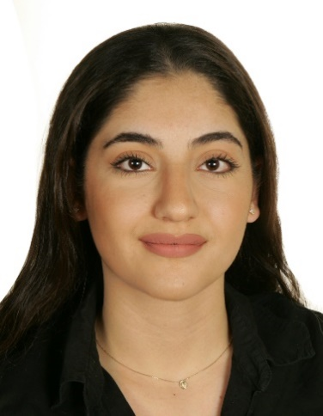
Daniella Bou Gerges

PERSONAL DATA:
First Name: Daniella
Middle Name: Dani
Last Name: Bou Gerges
Date of Birth: 21/ 1 / 1997
Place of Birth: Hammana, Lebanon
Nationality: Lebanese
Address: Zouk Mosbeh, Old Notre Dame De Louaize University Street
Mobile: 81/ 685842
Marital Status: Single
E-mail: daniellabougerges@gmail.com
EDUCATION:
- Bac II – Official Elias Abou Chabakeh High School – 2018
- Senior Undergraduate Student Studying Banking & Finance – Arts, Sciences & Technology University Kaslik, Lebanon
WORK EXPERIENCES:
- Middle East Airlines, Beirut International Airport, Cabin Crew 2019-2020.
- Assistant Manager at Lekme Al Baladi Restaurant 2017-2019.
- Customer Service and Promotor at Charcutier Aoun Jeita for 2016-2017.
- Sales, Marketing, Promoter and Customer Service Experience at GDR Agency 2015-2017.
- Sales & Digital Marketing at Basic Outlet Stores 2014-2015.
- Model United Nations (MUN) Advisor at Lebanese American University Jbeil 2019.
- Model United Nations (MUN) Delegate at Lebanese American University Jbeil 2017.
SKILLS and HOBBIES:
- Languages: - Arabic: Excellent
- English: Excellent
- French: Excellent
- Proficient with Microsoft Word, Excel and PowerPoint.
- Experienced with Adobe Photoshop.
- Photography Skills.
- Communication and Translation skills.
- Public Speaking, Research, Team Building, Writing and Debating Skills.
- Dancer for 8 Years and Taekwondo player for 4 Years.
- Basketball, Football and Volley player for 2 Years.
–––––––––––––––––––––––––––––––

