
Tripoli, Lebanon
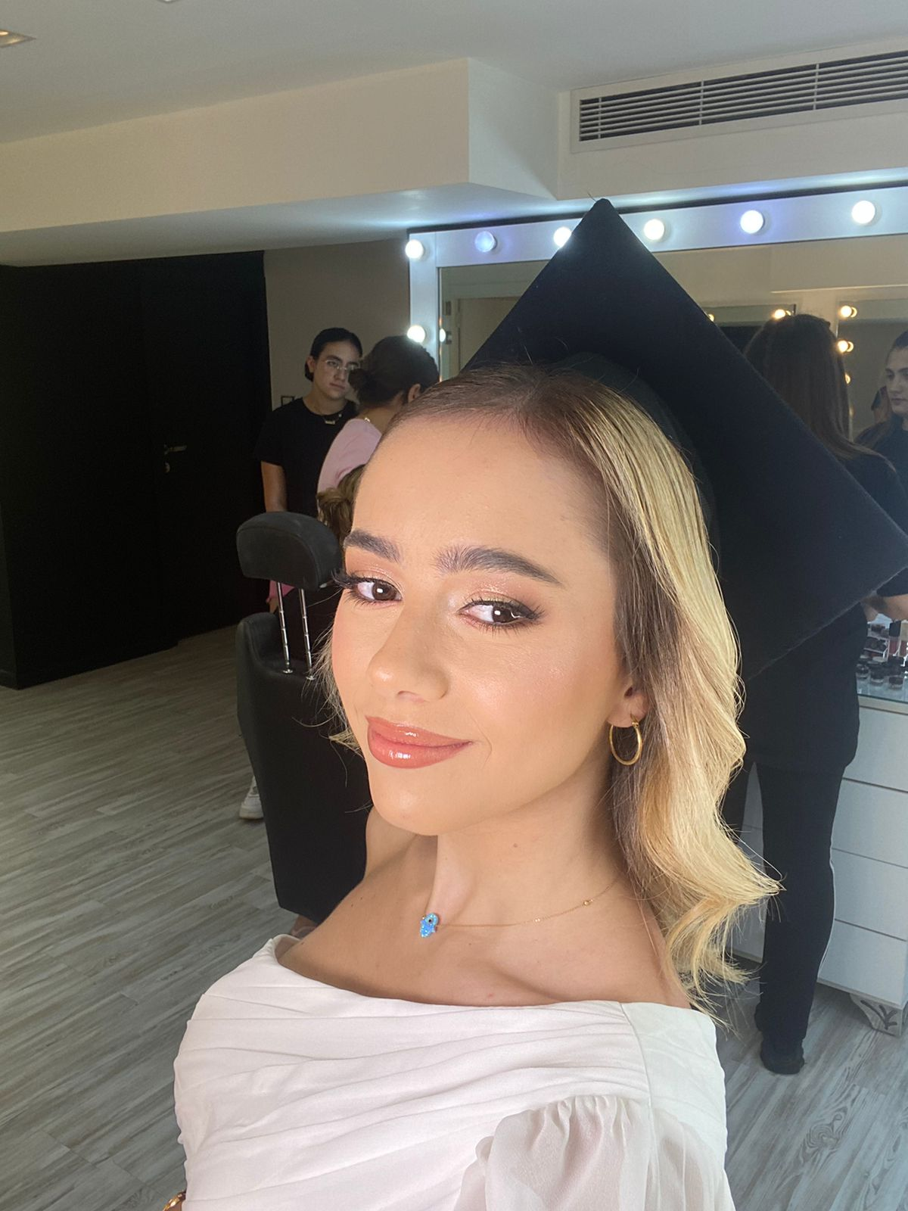 RASSIL EL SAYED

+961 70 877 810

Rassilsayed01@hotmail.com

Rassil El Sayed

Education
- Business Marketing (BBA) | Lebanese American University, Beirut, Lebanon SEPTEMBER 2019 – JUNE 2022
- Lebanese Baccalaureate | International School of Choueifat – SABIS, Koura SEPTEMBER 2003 – JUNE 2019

EXPERIENCE

ZAKA AI | MARKETING INTERN
• Worked with the marketing team on content creation related to Zaka’s social media platform
• Contributed in implementing innovative ideas for Zaka’s marketing strategies
PawPots BDD | Social Media Marketing
- Contributed in implementing social media strategies for their Instagram
GreenPeace MENA | Social Media, Digital Marketing Intern
- Worked on basic social media tasks: scheduling posts, ads reporting, daily engagement stats…


UNIVERSITY PROJECTS

GIPSY MARKETING STRATEGY| MARKETING 201
- Worked on enhancing gipsy marketing strategies to increase revenues & held interviews to analyze costumer behavior
- Was chosen to present the project to a Gipsy representative
ALWAYS MARKETING STRATEGY | MARKETING 498
- In-depth research on the company always
- Worked on a new marketing strategy for Always
P&G Market Analysis | Marketing 498
- Well-researched data on the company P&G


SKILLS
- Language Skills: Arabic (Native), English (Fluent), French (Basic)  - Software Skills: MS Office (Word, Excel, PowerPoint) | - Teamwork and leadership abilities  - Excellent writing & communication skills  - Photography & Graphic Design skills (Photoshop, templates…)
- Worked in public relations during school and university events  - Organized and choreographed annual dance evenings and talent shows during high school years  - President of LAU dance club  - Participated in Modern Arab League as a public speaker  - Member of the Fashion club  - Managed our school social media account | - Football, basketball, track and field school varsity teams  - Attended the SABIS Stars regional competition hosted in Dubai 2018 as a photography contestant  - Attended multiple workshops related to stock/ foreign exchange and business case studies  - Attended Sallama Sports Dance School for 12 years
EXTRACURRICULAR ACTIVITIES


AWARDS
- Awarded a full scholarship by The Middle East Partnership Initiative (MEPI Scholarship)  - 1st place at the 2017 UNESCO dance competition | - 1st place at the SABIS Local Football, Basketball, and Track & Field Tournament (Multiple) & 1st place at the Gymnastics Annual Awards (Multiple

