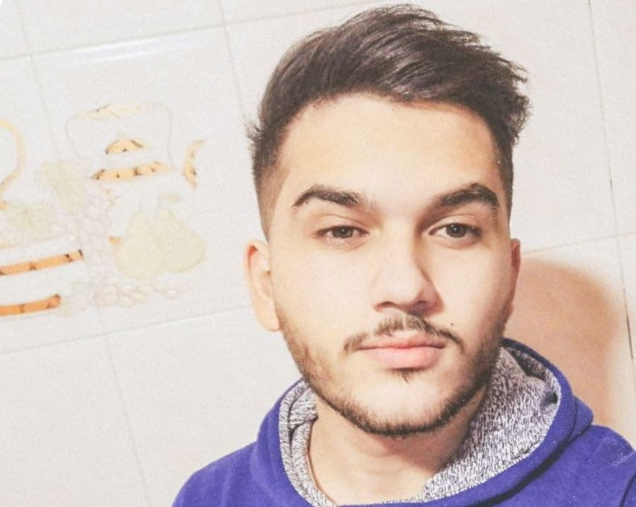

Contact
Address:
Barja, mount Lebanon,
Lebanon

Phone:
+961 76 061 990

Email:
wcbo123@gmail.com

LinkedIn:
https://www.linkedin.com/in/wassim-chebbo

Languages
Arabic
English 217
French

Hobbies
- Writing
- Sketching
- Photography
- Design

Summary
Computer Science specializing in application and web development. Experienced with all stages of the development cycle for dynamic web projects. Experienced in WordPress. Well-versed in numerous programming languages including HTML5, C++, MySQL.

Skill Highlights
- Project management  - Strong decision maker  - Complex problem solver | - Creative design  - Innovative  - Service-focused

Experience
Applications development - Android Studio - 01/2018 to 02/2019
Translating - TranscribeMe - 02/2021 to 03/2021
Waiter - Bahamas beach - 05/2020 to 09/2020
Waiter - Burger hills restaurant - 10/2020 to 3/2021
Waiter and cashier - La fontaine resort - 06/2021 to 8/2021

Education
Bachelor of Science: Computer Information Systems - 2018
Rafik Hariri University, LB

Certifications
Programming Languages: HTML5, C++, SQL, MySQL.

Wassim Chebbo

