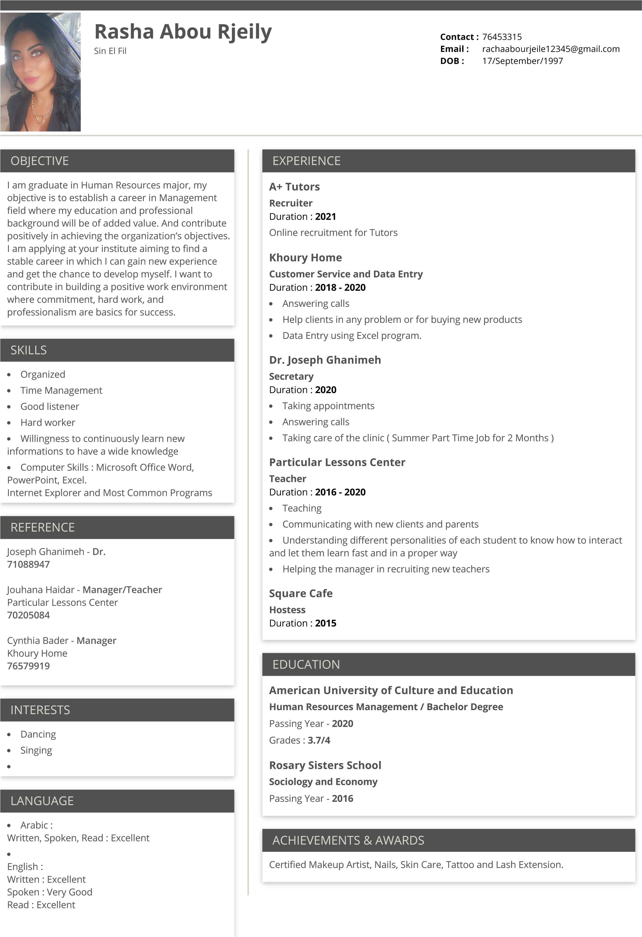
French :
Written : Excellent

Spoken : Very Good

Read : Excellent

