Ali Zeaiter  23th jan 1996, Lebanon
  Address: | Fanar
   | Mount Lebanon
  Mobile: | +9613543176
  e-mail: | Zeaiterali1@gmail.com

I am looking to build a career in a growing organization, where I can get the opportunities to prove my abilities by accepting challenges, fulfilling the organizational goal and climb the career ladder through continuous learning and commitment.

EMPLOYMENT DETAILS
Sofil Catering  Job title: Waiter (part time) | 1st July 2012 till 31 march 2014
The Sultan Center  Job title: Sales Assistant (Electronics Department)  Arope Insurance  Job title: Life insurance consultant  Roadster diner  Job title: Senior Waiter | 1st October 2014 to 4th February 2016  5th June 2020 to 30th September 2020  28th February 2016 to current

ACADEMIC BACKGROUND
MS in Computer and Communication Engineering  BS in Computer and Communication Engineering | Lebanese International University  Lebanese International University | Year completed: 2021  Year completed: 2019
Certificate of secondary education | Institut Moderne Du Liban | Year completed: 2014
Certificate of primary education | Institut Moderne Du Liban | Year completed: 2011

SKILLS
- Languages: Arabic, English and French
- Programming knowledge: mySQL, HTML, JavaScript, php, C, Java, Object Oriented, Data structure, Python, Bash/Shell, Assembly, LabVIEW
- Customer service, Time management, Highly committed, Creativity, Critical Thinking, Problem Solving, Public Speaking, Teamwork Skills, Communication, Collaboration.

PROJECTS
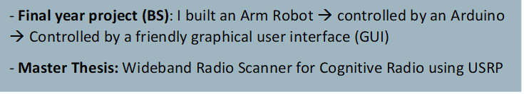
OTHER INFORMATION
Football is my hobby, Honesty, Team spirit, used to work under pressure and accepting challenges.
Declaration
I solemnly declare that all the above information is correct to the best of my knowledge and belief.

