
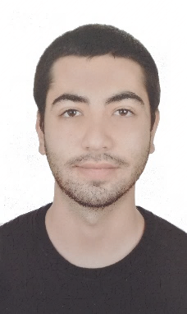
Roger Saoud
- roger.saoud@lau.edu Linked Portfolio  +961 79302696

Education

Bachelor of Science in Business Administration | May 2021 | Lebanese American University
GPA: 3.44/4.00
Marketing degree (Honors) with a background in Fine Arts and Design.
- Related coursework: Brand Management, Product innovation Management, Integrated Marketing Communications, Consumer Behavior, Design Studios

Skills & Abilities

Microsoft Office | Adobe Photoshop | Illustrator | Premiere | Autocad

Experience

Usher / Host | January 2019 – April 2019
- Managed effective communication with hostesses and hosts in event logistics for weddings, theatres, and concerts.
- Customer service management.

Graphic Design Lab Assistant | LAU | Sept. 2017 – July 2018
- Responsible for editing and modifying archive projects and websites.
- Assisted in organizing marketing campaigns for art exhibitors and promoting events through the university’s social circle.

Volunteer Work

Volunteer at Beirutopia | NGO | Feb. 2021 – April 2021
- Wrote a research paper including an action plan to support grassroots initiatives in Beirut.

Volunteer at the Red Cross | Sept. 2018 – May 2019

Other Certifications
IRB Research – Citi Program | Google Analytics | SEO HubSpot | First Responder

Languages
Fluent in English and Arabic

