ga  Career focus  Young and ambitious, seeking an opportunity where I can utilize my theoretical knowledge, interpersonal communication skills and experience performing Operations, Administration duties, and Communication.  Skills  - Highly collaborative: establishes positive working relationships  - Ability to plan long-term, organize priorities, multi-task and work under pressure with attention to details  - Has strong written and verbal communication skills  - Client service oriented: ability to respond to the clients and anticipate their needs  - Decision maker: can make decisions and take responsibility for them  - Flexible: ability to adapt to changes.  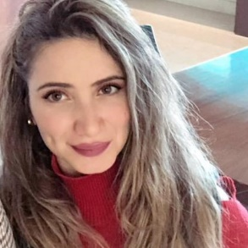 | Experience  Customer relation officer • united parcel services (ups & ucs) june 2015 – 2021  - Building rapport, listening, clarifying and managing conversational flows with customers  - Resolving conflicts and surpassing challenging situations  - Delivering outstanding services and building long term loyalty  - Working in both teams and self-directed environments…(etc.)  pORTAL cORDINATOR •Paragon BUSINESS IMP–Loubnany•  July 2021-pRESENT  Customer relation officer trainee• blc bank  apr – may 2016  teacher assistant•lebanese autism society  apr – may 2016  part time STORE KEEPER • Atchane fashion  sept 2009 - 2019  Education  Attended and achieved a license in Sales, Negotiation, Coaching and Customer Care  Wydner Coaches – September October 2015  license en sociologie industrielle, anthropologie et relations publiques  sept 2011 – july 2015 • universite saint joseph de beyrouth  Lebanese bac. • economy and sociology •  june 2010 • saint joseph de l’apparition
  ghina atchan
  Customer Relation Officer

