CUURICULUM VITAE
MARIAM RIZK
Computer Science

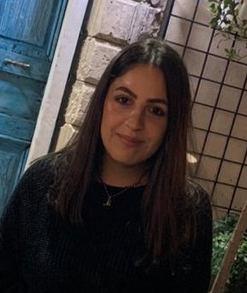

- Personal data :
- Full Name: Mariam George Rizk
- Date & Place of Birth: may 13, 2000, Qawzah, South of Lebanon
- Mobile: (+961) 70 387421
- Email: Mrizk0974@gmail.com

- EDUCATION:
Sept 01/2018-present Holy Spirit University of Kaslik-USEK
Lebanon
Major: Computer Science

July 07/ 2018 Our Lady of Annunciation School-Rmeich
Lebanese Baccalaureate in Life Science

- Experience:
Aug 20/2019-2020 Call Center agent , Malak Al Tawouk

November 13/2018 Assistant, Editor, Data entry Dany’s
April 12/2020 fashion Wear
Instagram

August 24/2019 Content creator, Learn.English.With.Fun.1
Present Instagram

Apr 2016 Sales woman, Danny’s Fashion Wear
Dec 2016 Qawzah, South of Lebanon

Summer 2015-2016 English tutor for kids, Scout
2017-2018 Qawzah, South of Lebanon

Apr 2016 Freelance educator
Aug 2018 Qawzah, South of Lebanon

- Volunteering:
July 2016 First Responder, Lebanese Red Cross
Aug 2016 Rmeich, South of Lebanon

- Special Skills:

Language Speaking Writing Reading

Arabic Fluent Fluent Fluent
English Fluent Fluent Fluent
French Confident Confident Confident
Computer literacy: Microsoft office ( powerpoint, excel, Word), HTML5, C++, C#, Python,Java Script, Linux.

