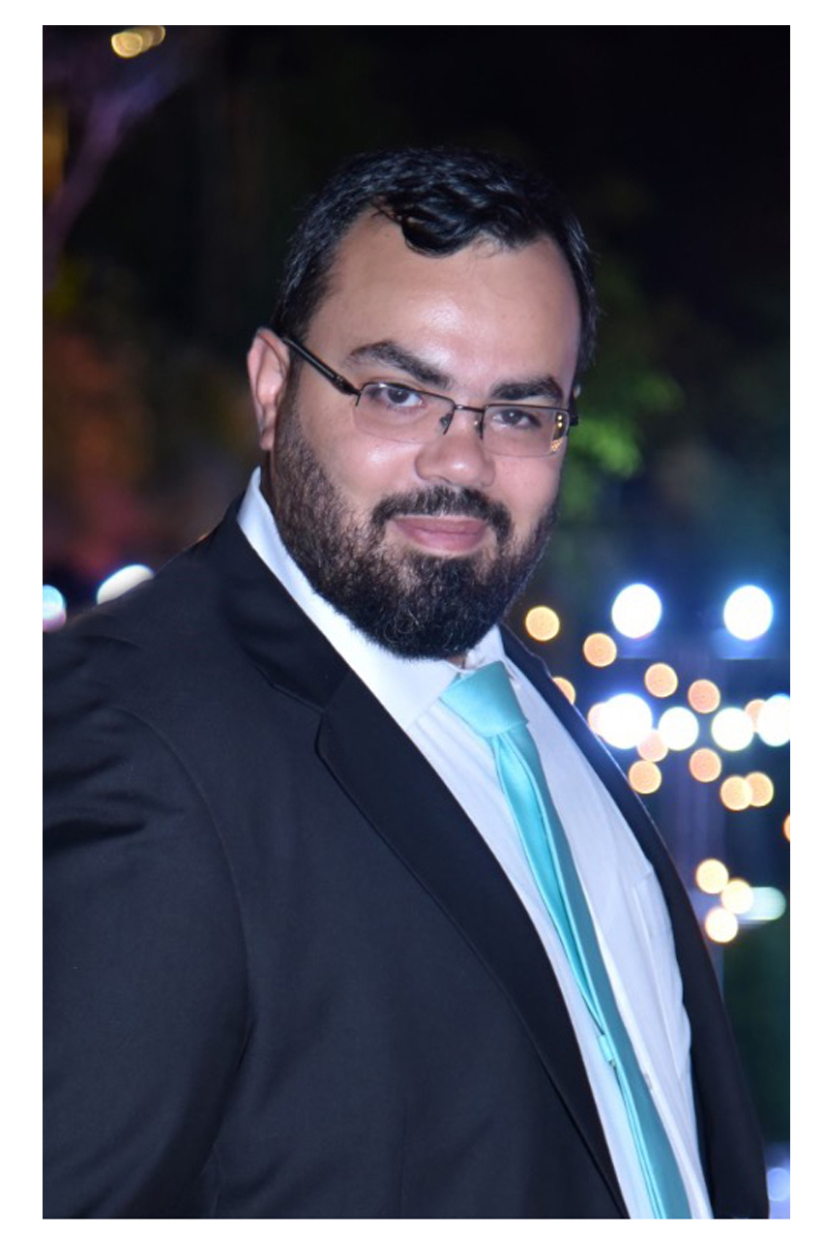 Khaled Sami Jamal Eddine
+961 70 639615 Address: Beirut, Lebanon

Khaled.JamalEddine@outlook.com
Khaled.JamalEddine@gmail.com

D.O.B: 1-1-1987 Marital Status: Married

Work Experience:

Mar 2021 – Present Ajialouna Organization Beirut, Lebanon

IT Manager

- Assign, co-ordinate and review projects and programs.
- Establish and implement policies and procedures for information systems.
- Manages and tracks the progress of different enhancement projects to include work plans, budgeting, status reports, administration, resource planning and control.
• Upgrades and maintains infrastructure (Servers and Network).
• Creates documentation supporting Technology direction.
- Responsible for all IT department purchases and Service Agreements.
- Plan, organize, direct, control and evaluate daily operations.
- Conducts business analyses to support strategic planning on required purchases, upgrades, and renovation. Negotiates satisfactory prices with multiple vendors according to ISO standards and regulations.
- Manages and provides technical and business direction that affects capacity planning, new applications, data security and LAN systems.
- Audit and implement all IT policies with respect to Security, Reliability, Performance, Redundancy, & Backup Solutions.
- Responsible for the following servers:
  - Active Directory (Domain), Systems Backup Servers, Update Server WSUS, Application Servers (Accounting, Operations)
  - Office 365 Management
  - Synology NAS storages
  - Sophos Antivirus Cloud Management
  - Virtual Servers Management (Hyper-V, VMware)
- Manage Network System and Responsible for all Network Devices (Sophos Firewall, Mikrotik router, Hp Switches and ISP Routers Management).
- Monitor network and system performance and implements performance tuning.
- Responsible for the migration of data from current systems to Microsoft Dynamics 365.
- Responsible for training users to work on Microsoft Dynamics 365.

July 2020 – Present AL Hayat International School (HIS) Aramoun, Lebanon

IT Consultant

Jan 2019 – Present NewYou Medical Center Beirut, Lebanon

IT Consultant

Sep 2011 – Mar 2021 AUL University Cola Branch Beirut, Lebanon

IT Operations Manager (Senior Systems and Network Administrator)
- Supervising total of 8 IT staff and Responsible for all Data Centers in AUL 7 Branches.
- Builds relationship with users and operations groups to find and solve problems.
- Resolves information technology services challenges by analyzing problems, finding the most appropriate solution, providing strategic direction, and redistributing resources as necessary.
- Responsible for all IT department purchases and Service Agreements.
- Responsible for finding new solutions to the whole IT infrastructure based on research and supply a written proposal to the CIO.
- Conducts business analyses to support strategic planning on required purchases, upgrades, and renovation. Negotiates satisfactory prices with multiple vendors
- Manages and provides technical and business direction that affects capacity planning, new applications, data security and LAN systems.
- Audit and implement all IT policies that were agreed on by the CIO, with respect to: Security, Reliability, Performance, Redundancy, & Backup Solutions.
- Responsible for the following servers in all seven branches:
  - Active Directory (Domain), Microsoft Exchange Server, Edge Transport Server, SCOM Server (Microsoft System Center Operations Manager), SCCM Server (System Center Configuration Manager), File Server, System Backup Server
  - Application Server (Linux Red Hat) – MySQL Platform
  - Office 365 Management
  - Update Server WSUS
  - Bitdefender Antivirus Cloud Management
  - Access Control Server and Application
  - Citrix VDI
  - Virtual Servers Management (Hyper-V, VMware)
- Manage AUL Network System and Responsible for all Network Devices in all seven branches (Cisco Switches and Routers Management).
- Monitor network and system performance and implements performance tuning (Bluecoat Packet Shaper, Proxy SG and Cisco ASA).
- Manages and tracks the progress of different enhancement projects to include work plans, budgeting, status reports, administration, resource planning and control.
- Ensure timely resolution and remediation of network security risks.
- AUL Website Administrator (www.aul.edu.lb).

Oct 2008 – Aug 2011 AUL University Sin El Fil Branch Beirut, Lebanon

IT Administrator

Teaching Experience:

- Computer Basics Course (IC3): since 2018 till present at AUL for students in the Business, Engineering, Humanities and Sciences Faculties.
- Networking 1 and 2 Labs: since 2009 till present at AUL for the second and third-year students in the Engineering and the Computer Science and Communication Faculties.
- Programming 2 using Java Lab: since 2009 till present at AUL for the second-year students in the Engineering and the Computer Science and Communication Faculties.
- Database Systems Lab: since 2009 till present at AUL for the second and third-year students in the of Engineering and the Computer Science and Communication Faculties.
- Operating Systems Lab (Linux): since 2009 till present at AUL for the second and third-year students in the Engineering and the Computer Science and Communication Faculties.
- Software Engineering Lab: since 2009 till present at AUL for the second and third-year students in the Engineering and the Computer Science and Communication Faculties.
- Management Information Systems Lab: since 2009 till present at AUL for students in the Business, Engineering, and Sciences Faculties.

Education:

Mar,2014 – Feb,2016

Arts, Sciences & Technology University in Lebanon (AUL)

MS (Master of Science) In Computer and Communication Engineering

Oct,2010 – Feb,2014

Arts, Sciences & Technology University in Lebanon (AUL)
BS (Bachelor of Science) In Computer & Communication Engineering

Oct,2004 – Feb,2008

Arts, Sciences & Technology University in Lebanon (AUL)
BS (Bachelor of Science) In Computer Sciences & Communication

2001 – 2004

Official Baccalaureate in Economics & Sociology

Technical Certificates:

- Cybersecurity Compliance Framework & System Administration (IBM, Coursera)
- IT Project Management (Indian School of Business, Coursera)
- Certified Information Systems Security Professional CISSP (New Horizons Training Center)
- ITIL Foundation V4 (New Horizons Training Center)
- Introduction to IoT (Cisco Networking Academy)
- Cybersecurity Essentials (Cisco Networking Academy)
- Introduction to Cybersecurity (Cisco Networking Academy)
- Cisco Certified Network Associate {CCNA 1,2,3,4} (Cisco Networking Academy)
- Action Centered Leadership (Smartman)
- Situation Leadership (Smartman)
- CompTIA Network+ Certified Professional
- Microsoft Certified Systems Engineer (MCSE 2008, AUL Extension Program)
- Microsoft Certified Systems Administrator: Security (MCSAS 2008, AUL Extension Program)
- Microsoft Certified Systems Administrator (MCSA 2008, AUL Extension Program)
- Microsoft Certified Professional (MCP, AUL Extension Program)

Association Membership:

- Member of Order of Engineers and Architects in Beirut, Lebanon since 2016 with an ID number: 49934
http://www.oea.org.lb
- Member in AUL-Alumni Since 2018
https://www.linkedin.com/in/aulalumni/
- Member in the Lebanese Civil Defense since 2008
http://www.civildefense.gov.lb

Computer Skills:

- Programming Languages: C++, JAVA, XML, HTML5, Java Script, PHP, SQL, VB.net, C#

- Operating Systems: Windows 7, 8, 8.1, 10, Advanced Server 2003, 2008, 2008 R2, 2012, 2012 R2, 2016, 2019, UNIX, Linux, Apple Macintosh.

- Expert in Microsoft Office 2010 / 2013 / 2016 / 2019 / office 365 / MS Project, Latex
- Computer Graphics: Adobe Illustrator, Photoshop

Languages:

Fluent in spoken and written Arabic and English, and simple in French and currently studying Turkish.

References:

Dr. Ahmad Hani El Fawal (Assistant Professor-Researcher and Post-Doc at Lab-STICC at ENSTA-Bretagne France)
Email: HaniFawal@hotmail.com
Mobile: +961 3 986979

Dr. Jihad Itani (IT Manager Chamber of Commerce Qatar, and CIO- AUL University)
Email: Jihad.Itani@aul.edu.lb
Mobile: +961 70 771991

Prof. Metanios El Halabi (President, AUL University)
Email: Metanios.ElHalabi@aul.edu.lb

Prof. Haytham Fawal M.D (CEO, NewYou Medical Center Lebanon)
Email: hayssam.fawal@bscnewyou.com
Mobile: +961 3 824228

Dr. Ahmad Abo Salem (Operation Manager, AL Hayat International School)
Email: Ahmad.AboSalem@his.edu.lb
Mobile: +961 71260430

