EXPERIENCE
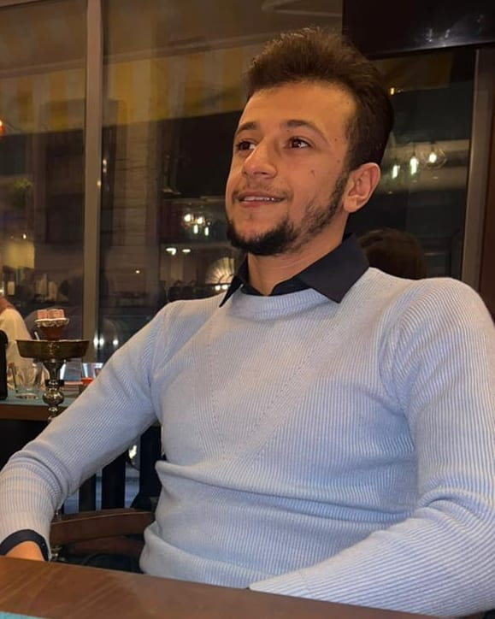
MAHMOUD SABRA
DETAILS
Address : Arab mosque
street , Burj-El- Barajeneh ,
Baabda , Lebanon.
T : 0096103747530
Mahmoudsabra.ms.ms@gmail.com
ABOUT ME
I am a passionate, sociable and leader material computer enthusiast looking for a position in a related field where I can thrive
SKILLS
Java ***
SQL ***
HTML ****
JS ***
CSS ***
VHDL ****
LTSPICE *****
English ********
German ***
French **
Microsoft office *******
IT sales representative, BEYTECH
Jdeideh, Metn state --- Nov 15th 2021 till present
My responsibilities are to memorize IT gadgets and help costumers in their navigation through the store and purchasing items. In addition to the organization, distribution of items and ensuring a good experience for the costumer , follow up for requests and problem solving .
EDUCATION
Computer engineering
Lebanese International University 2018—present
Diploma in economics and Sociology (SE)
SPSS –2017 (21st across Lebanon in official exams)

