
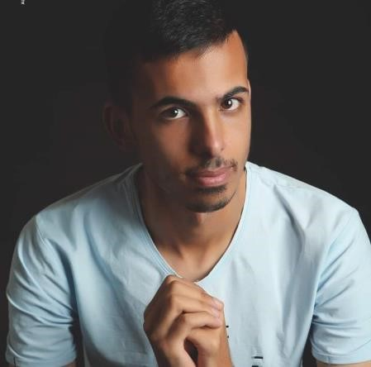

WASSIM ISSA

MARWANIYI

SOUTH LEBANON

Phone :

+961
79183448

Email:

wessoissa929@gmail.com

HOBBIES

Football

Traveling

EDUCATION

Manarat jabal
amel marwaniyi

BT ELECTRONICS
in
Amal institute

University

Computer
science at lebanese international univer
sity LIU

2
semesters to grad
uate

Experience

I have some projects I submit them

:
Software engineering project (Blood Bank
)

:
Web programming client side project (html w css w Javascript
)

:
Mobile
application (Android studio) 2 projects one without
database and one with database

:
And the senior project is done

I work in a electonics store

SKILLS

Visual Studio /C#/C++/SQL management Studio/Visio/Android studio/Arduino/Php/Python/Database/
Netbeans/Java/ Microsoft office / Social Media

Languages

English(very good)
–

French( good)
–
)
Arabic ( fluent

