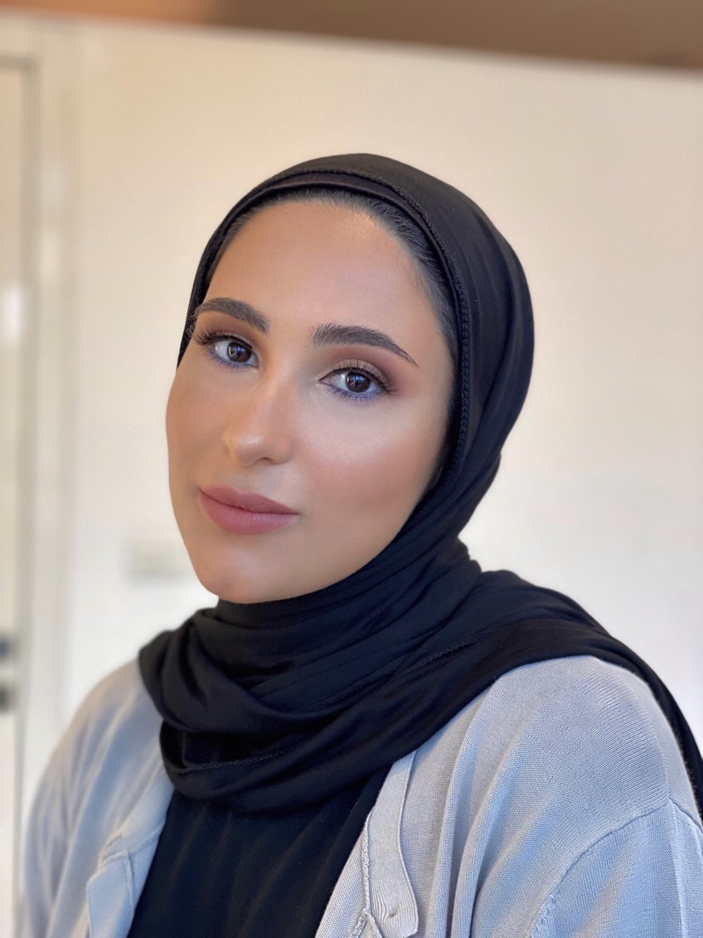
Tia Akil
23 yo • Beirut, Lebanon
+961 (70) 697 555 • akiltia@gmail.com • tia.akil@lau.edu.lb
EDUCATION | Lebanese American University September 2017 - May 2021 School of Business- BS in Business Marketing  Attended American Community School 2003-2017
EXPERIENCE  ACTIVITIES | SAWA NGO | Sales representative Internship August 2021-October 2021  - Developed a new technique to communicate with our customers through live chat services on social media during the pandemic  - Led a group workshop that allowed Syrian women refugees engage with the younger generation and teach them their handcrafting skills.  - Managed Instagram page and created innovative videos , stories and posts as well as monitored engagement on page.  - Orchestrated an in-store experience for our visting donors by creating a warm atmosphere and layout resembling the brand qualities and values  Entrepreneur CEO of OUT OF AREA | Independent work 2021- Current  Lebanon  - Experienced failure with an initial idea of sustainable up cycled clothing, but inspired me generate a new idea that came through.  - Urbanizing the modest community by making my unique contemporary taste available to others.  - Entered retail market by analyzing a niche market and offering them high quality modest clothing at a decent price.  - Developed and executed a go to marketing strategy backed by primary research based analysis and personal experience  - Achieved an overall revenue growth of 13% in the end of the first year.  Rayhana Organization NGO | Marketing Assistant 2017 - Current  Lebanon  - Exposed to several diverse families and established ways to adapt to their habits and norms in order to assist them in various situations.  - Developed a marketing plan by showcasing NGO across several social media despite the Covid crisis.  - Used paid media to reach our niche market.  - Developed partner outreach strategy by hosting events as well as through word of mouth of close families and friends  - Used the strategy of NGO to move into extreme cases that are overlooked by other NGOS, which increased demand from people and families.  Freelance Stylist | Independent work 2019 - Current  Lebanon  - Elevate young girls confidence despite societies stigma  - Built a network of diverse connections  - Allowed me to begin building my title and exposing my talent to others  - Sharing my fashion sense with other girls that had a common goal  Careem Project | University Project April 2019  Lebanon  - Pitched brand strategy refresh to Careem company and had discussion with founders of Careem while still being a student  - Introduced an original approach of customer experiences for customers using the service.  - Debated the importance of paid online media in logistics  - Had a budget of 3,000$ but only spent 1,000$  Sister School | President September 2016 – May 2017  Lebanon  - Elevated livelihood of children by raising funds to improve school environment and provide better education  - Led and organized a garage sale to collect items people no longer needed that could be donated and beneficial to the schools  - Raised 1200$ to refurbish a music room and providing new sports equipment
SKILLS  PERSONAL INTERESTS | - Bilingual – English (Highly Proficient) and Arabic (Fluent Speaker)  - Teamwork  - Communication  - Adaptability  - Leadership  - Prioritizing  - Scheduling  - Proficiency with computer programs (Microsoft, PowerPoint, Excel)  - Building Brands  - Sustainability  - Fashion Design/ Designing clothes  - Blogging / Writing  - Planning and Organizing

