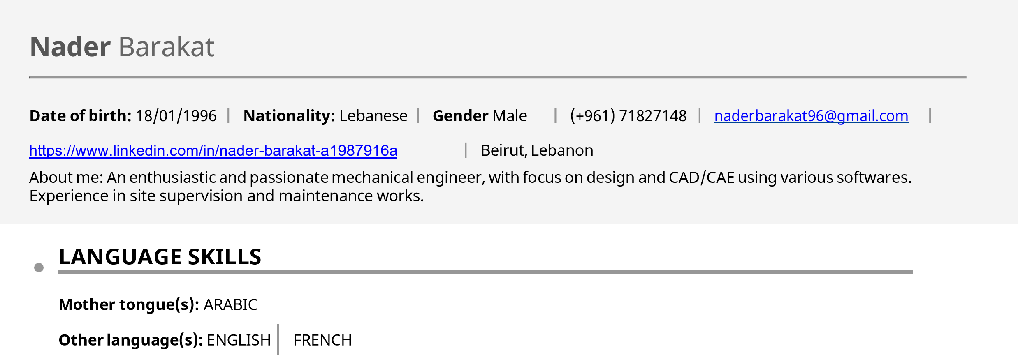
WORK EXPERIENCE

09/2021 – CURRENT – Beirut, Lebanon Design Engineer – 3E CONTRACTING

- 2D shop drawings and P&ID diagrams of water treatment systems using AutoCAD.
- Site supervision and integration of systems.
- Daily report writing and communication with upper-management.
- Project planning, pricing, and BOQ.

02/2018 – 01/2019 – Beirut, Lebanon Maintenance Engineer – Dairy Day

- Planning and undertaking scheduled maintenance
- Responding to breakdowns
- Diagnosing faults
- Ensuring compliance with health and safety legislation
- Creating maintenance procedures
- Managing stocks of supplies and equipment.

10/2019 – CURRENT – Beirut, Lebanon Event Coordinator – Select Hosting Agency

- In charge of events with over 3000+ attendees
- Coordinate 500+ VIP guests and corporate events
- Manage promotional campaigns for international brands
- Coordinate with vendors to ensure guidelines and concepts are applied
- Floor Manager at event “Joy Awards” by MBC group.
- Floor Coordinator locally and internationally by Toni Breiss, Bluemarc Events, Ghada Blanco, Fadi Fattouh, Strawberry and champaignes with Jessy Karam, and others.

10/2018 –CURRENT – Beirut, Lebanon
Guest Service Supervisor – Freelance

- Team leader in weddings, promotions, conferences, concerts, VIP dinners and all kind of International events
- Greet and direct guests to appropriate areas as needed throughout the event.
- Provide leadership, guidance, and support to the team, and deliver superior customer service to all clients.
- Supervise Hosts/Hostesses and act as primary management contact for clients
- Demonstrate high level of professionalism representing the company both internally and externally

EDUCATION AND TRAINING
11/2018 – 06/2020 – Beirut, Lebanon
MASTERS OF SCIENCE IN MECHANICAL ENGINEERING – Lebanese International University

11/2015 – 06/2018 – Beirut, Lebanon
BACHELORS OF SCIENCE IN MECHANICAL ENGINEERING – Lebanese International University

DIGITAL SKILLS
AutoCAD SolidWorks MATLAB Microsoft O_{ffi}ce Ansys Java Troubleshooting

COMMUNICATION AND INTERPERSONAL SKILLS

Personal Skills

Excellent written and verbal communication skills.
Ability to work independently or as a part of a team.
Excellent problem solving abilities using critical and progressed thinking. Proven leadership and ability to motivate.

