Problem 1

E(q0) = q0q3
E(q1) = q1
E(q2) =q2
E(q3) = q3
E(q4) = q4q3

- bbb is accepted
- aaab is accepted
- { w ∈ {a,b} | w contain (3a,b)}

δ | a | b | ε
q0 | q1 | Φ | q3
q1 | q2 | Φ | Φ
q2 | q0 | Φ | Φ
q3 | Φ | q4 | Φ
q4 | Φ | Φ | q3

δ’ | a | b
q0q3 | q1 | q4q3
q1 | q2 | Φ
q4q3 | Φ | q4q3
q2 | q0q3 | Φ
Φ | Φ | Φ

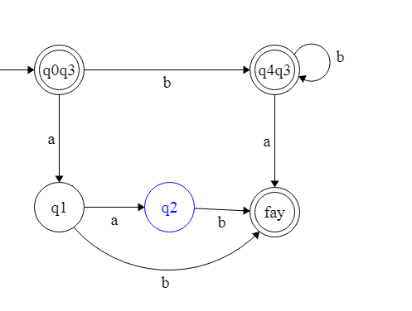

Problem 2
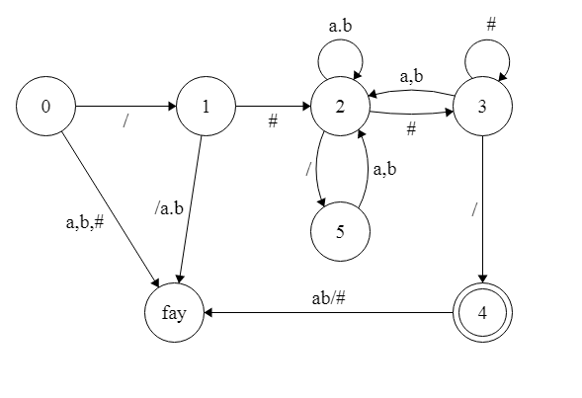

Problem 3

1
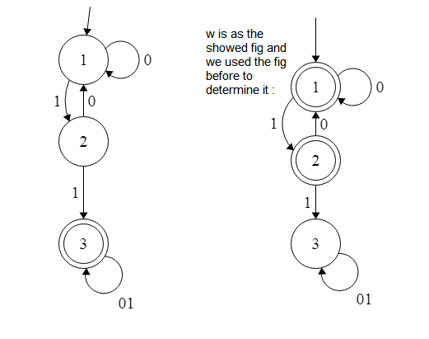

2

3
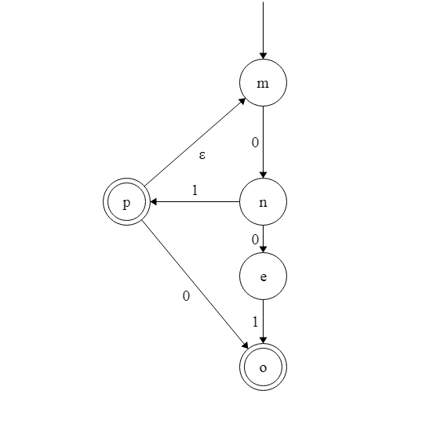
Problem 4
Let M= (Q1, Σ, δ1,q1,F1) recognize Z1
Construct R =(Q, Σ, δ,q0,F) to recognize Z1 fliped
Q=Q1 , the same states
q0=q1 same start state
F=F1 same final state
Define δ so that for any q ∈ Q and any a ∈ Σ
δ (q, a) ={
δ1(q, 0) if a = 1
δ1(q, 1) if a = 0}

