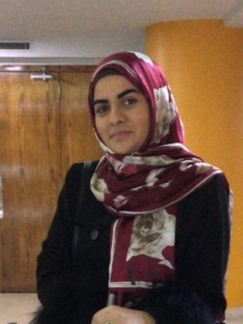 |  |  |  | Fatima Melhem  Fouani  “You don’t build a business, you build people, and then people build the business.”

Experience
EVOLVE SOLUTIONS (1/10/2021-to present)
Currently working as an online HR specialist performing different HR related task.
Work study program(fall2019-2020)
Worked, as an assistant to the faculty’s assistant in activities such as organizing, photocopying, writing and translating.
Volunteered in ministry of social affairs ( shayah)
Worked as an English teacher for kindergarten students for a month.
Summer activity club
Worked as an activity teacher for kids in a summer club for the period of 2 month and took a supervisory position for a period.
Tutoring
Worked as a private tutor in summer for kids who needed help in their school entrance exams.

Education
Al Maaref university , (2020,2021)
- Graduated in Human Resource Management major with a GPA of 3.8 and made the honors list for several semesters and delivered the commencement speech.
- Online courses: leadership in the 21st century
- Attended an online conference (resource for humans) by lattice and a series of several webinars.
- Completed “ Human Resource Program” By General Electric
- Completed “People Management Skills” by CIDP
- Completed “ Strategy Consulting “ by BCG

Skills
Communication and interpersonal skills
Leadership skills
Ability to work in teams
Basic MS office word skills
Basic MS EXCEL skills
Judgment and Decision Making
Reading Comprehension
Management of Personnel Resources

Languages
English : fluent
Arabic: fluent

References
Dr. Ali Dirani
Assistant Dean at Al- Maaref University
Phone: 70/326013
Email: Ali.dirani@mu.edu,lb
 |  | Linkedin.com/fatima-fouani-2bb404194
 |  | 70/643489
 |  | fatimafouani@hotmail.com
 |  | 10118217@mu.edu.lb
