BATOUL SAAD
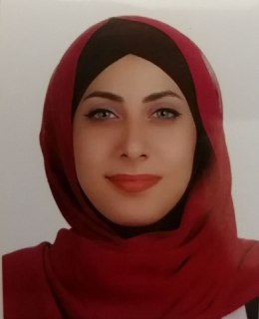

Personal Information
- Place and date of birth: Beirut – 09/03/2000
- Nationality: Lebanese/Canadian
- Mobile: +961-78-883038
- E-mail: batoulsaad23@gmail.com

Objective
A Translation Masters student who has the desire to work in an institution and participate in supporting its goals while building my professional career, eager to learn anything and everything that paves the way to a better me.
An organization or institution where I will have the chance to exercise and apply my educational and practical experience to contribute in developing its objectives.

Education
- November 2020 - Present: Islamic University of Lebanon
- Master’s degree in translation
- October 2017 - June 2020: Lebanese International University
- Bachelor’s degree in translation (English, French and Arabic in all majors and combinations)
- September 2016 – July 2017: Lycée Uléma Subhi al Mahmasani
- Lebanese Baccalaureate in Economy and Sociology

Professional Experience
- 11 January 2021 – 11 April 2021: Translation and Documentation intern at the ADHRB Organization (Americans for Democracy & Human Rights in Bahrain): Translating English, Arabic and French documents; Editing and Proofreading documents; taking notes in online events.
- 2 October 2020 – 17 November 2020: Correcting foreign students’ projects and assignments on behalf of their instructor.
- 24 July 2020 – 24 January 2021: Online tutor: Tutoring foreign students languages such as Arabic, French, English and Spanish online; Tutoring math, science, English and Arabic to an autistic boy.
- February 2020: Editor and Proofreader: Editing and proofreading senior projects for students.
- January 2020 – January 2021: Translation Internship at Hult Prize Lebanon: Translating documents; Editing and proofreading documents.
- March 27, 2019 – July 2019: Freelance Translation: Translating all sorts of documents, except for legal documents.

Computer Skills
- MS Word
- Excel
- PowerPoint
- Internet Use
- Adobe Photoshop

Languages and Skills
- Fluent in English, Arabic and French (DELF B2) with basic knowledge (DELE A2) in Spanish (writing, reading and speaking) and Beginner in Turkish.
- Soft skills: Leadership, Communication, Organizational, and Management.

Extracurricular activities

Reading

Playing Basketball, Volleyball and Tennis

Hiking

All documents and references shall be furnished upon request.
Last updated July 2021

