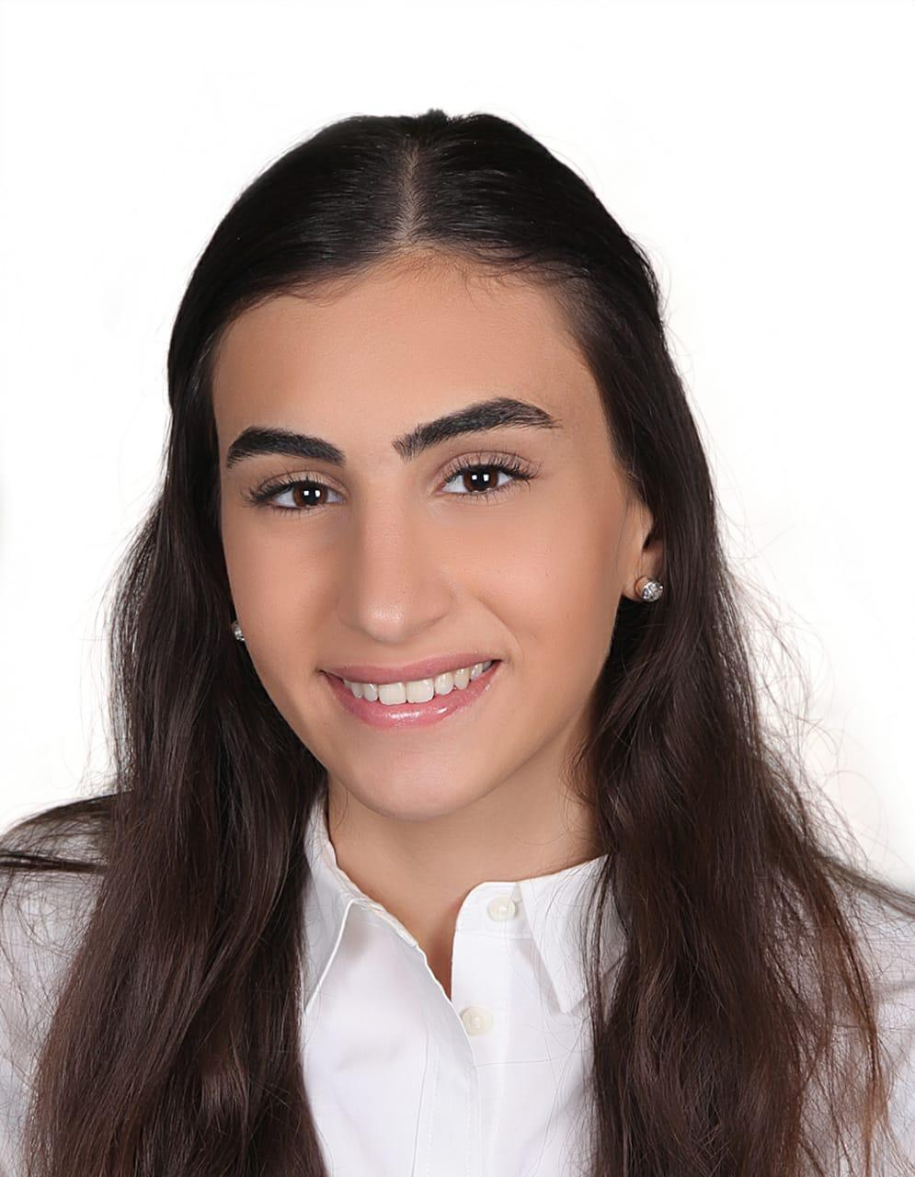 |  | nadin barzi  Finance
Nationalities  Brazilian  Lebanese  Contact  PHONE:  00961 70644253  Location:  Baaloul-West Beqaa  EMAIL:  Nadinalbarzi@hotmail.com  languages  English - fluent  Arabic - Native/Fluent  Spanish - Intermediate  Portuguese - Low intermediate |  | EDUCATION  AUST  2018 - 2022  Bachelor degree in Finance  GPA= 3.5/4 (With Distinction)  Qaroun High Public School  2015 - 2018  Lebanese Baccalaureate 2 in Life Science  17.18/20 (Very Good)  WORK EXPERIENCE  Qaroun Bay- customer service  2020–2022  - Welcoming and greeting customers  - Taking orders  - Dealing with problems patiently  - Tasking customer feedbacks and farewelling them  Al Hamoui Pharmacy -Cashier  2018–2019  - Bagging items carefully  - Understanding customer base  - Verbal communication skills  - Cash handling  Social Cultural Club-Social Worker  2018–2020  - Identify those in need  - Advocate for and develop plans to improve clients’ well-being  - Respond to clients in crisis situations  SKILLS AND COMPETENCIES  - communication and interpersonal skills: excellent  - High accuracy and Multitasking  - High approachable, Confidential and Trustworthy  - Problem Solver  - Innovative Critical Thinker  - Self-motivated and Active learner  - proffessional skills  - Microsoft Office: Excellent  - Cultural Knowledge: great  - Organizational and Team working Skills: Excellent  awards and certificates  ICDL-International Computer Driving Lisence  - European Computer Driving Lisence foundation  American University of Science and Technology

