Profile  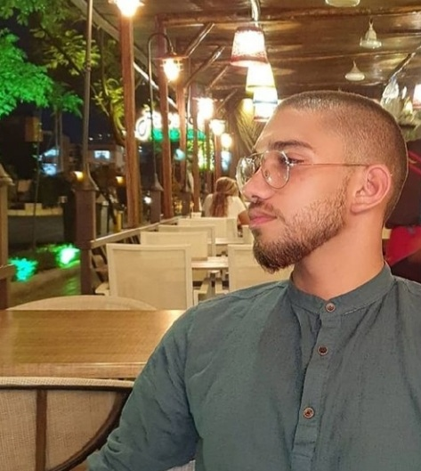  Nationality : Lebanese  D.O.B : 3-4-2000  Sex : Male  Marital Status : Single  Address : Beirut-Barbour Street  Kharma Building 6th  Floor  Contact  PHONE:  +961 81 727 922  EMAIL:  julianogharzo360@gmail.com  Hobbies  -Mobile Maintenance (Certified From MIRA Training Center)  -Video Editing and Photoshop  -Poetry and Story Writing  -Piano  Language  Excellent in English , French and Arabic (Reading , Writing and Speaking)  Computer Skills  - MS Office  - Java Programming Language  - PHP  - Procedural SQL AND SQL  - HTML , CSS  - Javascript  - JQuery  - Ajax |  |  | juliano  gharzeddine  Manager- Teacher  EDUCATION  Sagesse Achrafieh 2003– 2018  -Graduated in 2018 – BAC 2 Official Degree In General Sciences  - A+ in Mathematics and Physics  LE CNAM – Lebanese University 2019 - Present Date  Third year of Software Engineering  WORK EXPERIENCE  E.S.E.N – Math and Physics Instructor and Private Teacher October 2018 – Present day  Diet Delights Nutrition Center June 2019 – July 2021  Responsibilities and Duties :  -Customer Subscription Supervisor  - Inventory and Schedule Manager  -Training Assistant  - Branch Manager  McDonald’s - Swing Manager 2015-2018  Responsibilites and Duties :  -Customer Service And Handling Customer Complaints  -Shift and Schedule Management  -Inventory Control  -Training And Formation of new recruits with a detailed explanation of the required procedures  PAUL ( French Cuisine ) – Team Leader 2018  Responsibilities and Duties :  - Assuring smooth customer service and accurate order taking  - Inventory control and schedule assistance according to projection hours

