Curriculum Vitae

Name: Elias kimaz
Address: Lebanon – between Zahle and Haddath
Date of birth: 25- Aug - 1999
Marital Status: Single
Phone # +961 8 810090 , +961 5 461275
Mobile # +961 71090989
e-mail: eliaskimaz53@outlook.com

Education:

2015: Brevet (Ecole Saint Joseph Salvatorien -Zahle Houch el Omara)
2019: BT3 information technology (ETSTC- Dekwaneh)
2022: Third years computer science (USEK- Zahle)

Work Experience:

July 2018: Imaz Trading.Co (Zahle - Lebanon)

Sales Representative: (Electronics section Sony - Samsung - Casio ...etc.)

June 2019: Imaz Trading.Co (Zahle - Lebanon)

Showroom Manager: (Electronics section Sony - Samsung - Nintendo - Casio...etc.)

April 2021 till August 2021: Certificate in Web developer with Tech for Youth by USAID (Ferzoul - Lebanon)

June 2021 till january 2022: Waiter at Hotel albergo (Ashrafiye)

January 2022 till now: It support at connect (Naher Al Mot)

Competencies:
- Professionalism: Excellent knowledge of security management
- Teamwork: Works collaboratively with colleagues to achieve organizational goals
- Planning and Organizing: Develops clear goals that are consistent with agreed strategies

Computer skills:

Microsoft Word, Excel, SQL, Access & Internet

Programing Skills:

Html, CSS, JS, C++, Java, dotnet core, dotnet framework, API

Languages:

Arabic (Mother Tongue)
French (Good)
English (Very Good)

Personality:

Dynamic, Quick learner & hard working

Hobbies:

Basketball, Swimming & traveling

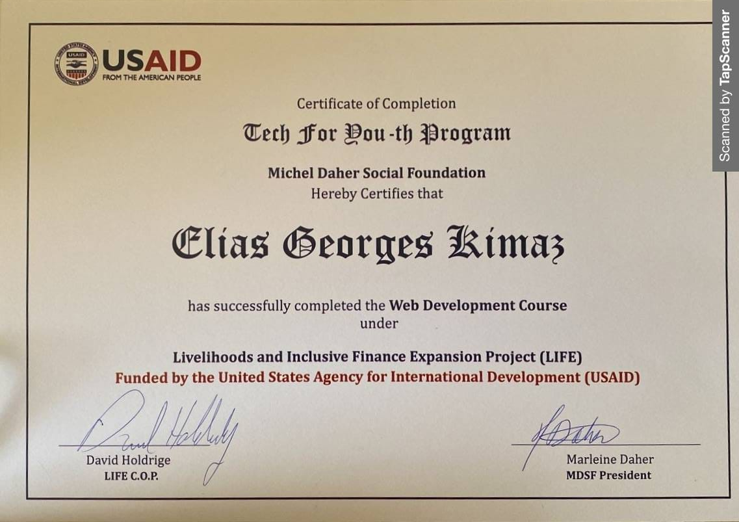

*References: Recommendation available upon request

